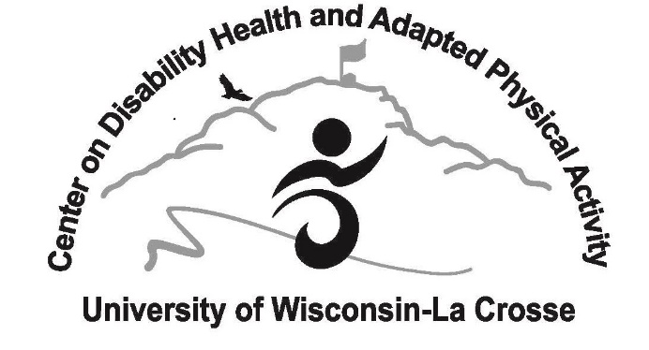
Office Use Only
Date Received:

Physical Activity Mentoring Program

Participant Information Update/Enrollment Form

To Parent/Legal Guardian: To participate in the Physical Activity Mentoring Program at UW-La Crosse, please complete this form as accurately as possible. All information is necessary to maximize safety and will be kept confidential. Please use the back of the page if you need more space. Incomplete information may delay enrollment into the program.

Participant’s name__________________________________________________ Gender: ☐M ☐F

Age_______________ Date of Birth_____________________________

Parent/Guardian name __________________________ Relationship to Participant_________________

Parent/Guardian address________________________________________________________________

Parent/Guardian phone__________________________________________

Parent/Guardian e-mail_________________________________________________________________

Emergency contact (In case parent(s)/guardian(s) cannot be reached):

Name__________________________________________________ Phone_______________________

Relationship to participant _________________________________

NOTE: In case of an emergency, the Mentoring Program of another agency may notify 911 or another emergency medical service which could result in transportation of the participant for appropriate care.

Participant’s Primary Physician ____________________________ Hospital_____________________
May we contact the physician above? Yes No Phone: _______________________

SCHOOL INFORMATION (IF COMPLETED, PUT HIGH SCHOOL INFORMATION)
School Building: Placement (Regular or Special Education):
School District: _______ City/State: _____________________________
Does student have an IEP? Yes No Are physical education goals on IEP? Yes No
Classroom Teacher: ___________________________ Phone: ___________________
Physical Education Teacher: Phone: ___________________
Social Worker: __________________________________ Phone: _______________________________
Can we contact the school personnel listed above? Yes No

DISABILITY (Check all that are applicable)
ADHD
Autism ___ Mild ____ Moderate ____ Severe
Asperger Syndrome
Cerebral Palsy ___ Mild ____ Moderate ____ Severe
Cognitive Disability ____ Mild____ Moderate____ Severe
Down Syndrome
Emotional/Behavior Disorder
Hearing Impaired: Please indicate level of residual hearing: __________________________________
Muscular Dystrophy
Specific Learning Disability – Specify. ____________
Spina Bifida
Traumatic Brain Injury/Head Injury
Other Motor Disorder – Specify. ______
Visual Impairment: Please indicate level of residual vision: ___________________________________
Other condition(s) requiring special care – Specify. ______

Does the participant require any assistive devices, braces, or a wheelchair? Yes No
If yes, what:
OTHER HEALTH-RELATED/MEDICAL INFORMATION:
Ht: _____’ _____” Wt: ______lbs.
□ Asthma/Severe Allergies
□ Food allergies – Specify food(s) ______
□ Non-food allergy – Specify ______ _____
□ Latex allergy
□ Cystic Fibrosis
□ Diabetes
□ Epilepsy/Seizure Disorder – What type of seizures? How frequent are the seizures? ______
______
□ Gastrointestinal or feeding concerns including special diet and supplements
□ Other condition(s) requiring special care – Specify.

MEDICATIONS
Is the participant on any medications? Yes No If yes, for what ______
Additional information that may be helpful about medications for mentors working with the participant:

GENERAL CHARACTERISTICS OR BEHAVIORS
PLEASE COMPLETE ALL OF THE FOLLOWING QUESTIONS:
- Is there a Behavior Intervention Plan in place at home or at school (on the IEP)? Yes No If yes, please attach copy.
- Can we discuss this plan with school personnel? Yes No
Name of school contact : ____________________________ Phone Number: _______________
- Any self-injurious behaviors? Yes___ No___ If yes, what: ______
- Communicates orally? Yes No
- Uses picture icons or other visual supports? Yes No
- Does the participant wander? Yes No
- Any aggressive behavior? Yes No
- Self-manages frustration and anger? Yes No
- Toilet trained? Yes No If no, uses diapers? Yes No
- Does participant indicate a need to use the bathroom? Yes No
- Uses the toilet independently? Yes No
- Changes clothes for swimming independently? Yes No
- How much prompting and assistance needed to participate in activities? Much Some
None
- Understands basic directions (left, right, over, under)? Yes No
- Understands basic number concepts? Yes No
- Tells time and understands the concept of time? Yes No
- Can identify colors? Yes No
- Will indicate a physical activity preference? Yes No
- Will play/interact cooperatively with others? Yes No
- Will play/interact cooperatively in a small group? Yes No
- Will easily adjust to changes in routine or schedule? Yes No

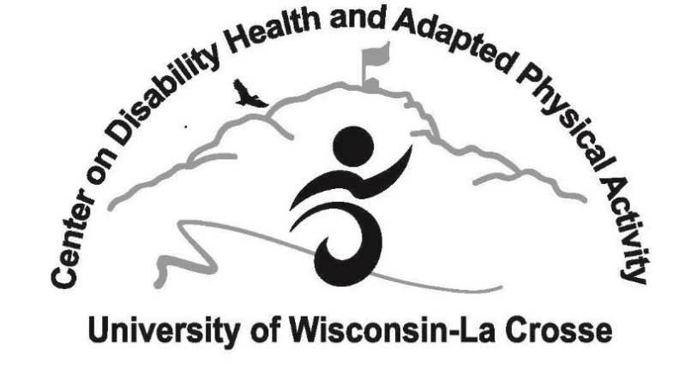

Physical Activity Mentoring Program
Emergency Release Form
Name of Child (please print) ______________________________________________________
As legal guardian/parent, I give permission for the above-named individual to receive emergency medical care in case of injury that may occur during the Children's Motor Development Program. I agree to defend, hold harmless, indemnify and release the Board of Regents of the University of Wisconsin System, the University of Wisconsin-La Crosse, and their officers, employees, agents, and volunteers, from and against any and all claims, demands, actions, or causes of action of any sort on account of damage to personal property, or personal injury, or death which may result from participation in the above-listed program.

__________________________________ ___________________________ __________________
Parent or Legal Guardian Signature Date

Should my child be involved in an emergency situation, s/he is to be taken to the:
________________________________ Emergency Room.
(Hospital/Clinic Name)

My family doctor is ______________________________________

If I cannot be reached, please contact:

Name _________________________________________Phone ________________________

Address _____________________________________________________________________

Relationship to child______________________________________

Center on Disability Health & Adapted Physical Activity
108 Mitchell Hall; 1725 State St
La Crosse, WI 54601
Office Phone: 608-785-8691
awagner@uwlax.edu
Photo and Video/Testimonial Release Form
Copy and reuse form as needed

I/We hereby confer upon the University of Wisconsin-La Crosse, the University of Wisconsin-La Crosse Alumni Association and the University of Wisconsin-La Crosse Foundation the unrestricted and irrevocable right and permission with respect to the photographs and/or video taken of me or my children or in which we may be included with others:
- To use, reuse, publish and republish the same intact or in part, separately or in conjunction with other photography, in any medium now and hereafter known, and for any purpose whatsoever (including illustration, promotions, advertising and trade) and;
- To use my name and any testimonial I have provided to the university in connection therewith if UWL so decides.
I/We hereby release and discharge the photographer and/or videographer and the University of Wisconsin-La Crosse, the University of Wisconsin- La Crosse Alumni Association and the University of Wisconsin-La Crosse Foundation, from all and any claims and demands ensuing from on or in connection with the use of the photographs including any and all claims for libel and invasion of privacy.
I/We have read the foregoing and fully understand the contents hereof.

(Subject’s name and signature) Phone Number (Date)
When securing releases from multiple subjects it is acceptable to use one release form signed by all relevant persons. You may use the back of this form for additional signatures.
PHOTOGRAPHY AND VIDEOGRAPHY RELEASE OF MINOR(S)
I have read the foregoing and fully understand the contents hereof. I represent that I am the (parent/guardian) of the below named subjects. I hereby consent to the foregoing on his/her behalf.
Name of Parent or Guardian__________________________________ Minor Name(s) __________________

Click or tap here to enter text.
_______________________________________ ____________________________________
(Parent or Guardian Signature)

Address____________________________________________________________________________________________________

City ____________________________________________________________ State___________Zip________________________

Phone _________________________________________ Email ______________________________________________________

_________________________________________________________________________________________________ __________________
(Witness Name and Signature) (Date)

For office use: Photo and Video/Testimonial used for______________________________________________________________________________

Photographer/Videographer ___________________________________________________________

Physical Activity Mentoring Program for Persons with Disabilities
Medical Clearance Form-Health Approval to Participate Statement

On this date, I examined ________
Print Name of Participant
On the basis of the examination and medical history furnished to me, this individual may participate in the Physical Activity Mentoring Program for Persons with Disabilities fully or may participate with the limitations noted below.
Cleared; with no physical activity limitations.
Cleared; with the following physical activity limitations_____________________________________
_____________________________________________________________________________________
_____________________________________________________________________________________
Not Cleared; for the following reason(s): _________________________________________________
_____________________________________________________________________________________
_____________________________________________________________________________________

__________________________________ _________________
Signature of Licensed Health Care Provider Date of Examination
_________________________________
Printed Name of Licensed Health Care Provider MD/DO/PA/CNP/FNP
_________________________________ ____________________
Place of Employment Telephone
_____________________________________________________________________________________
Participant (or Parent/Guardian if under 18) Signature Date

Return to: Physical Activity Mentoring Coordinator
Center on Disability Health
1725 State St; 108 Mitchell Hall
La Crosse, WI 54601
Mentoring Program Overview for Parents and Participant

The Mentoring Program…
- Is a physical activity program for persons with disabilities, ages 5 and above.
- Provides participants with college student mentors who are physically active, fun, encouraging, motivating, and supportive of persons with disabilities.
- Requires participants to meet with mentors for 2 hours per week for a minimum of 8 weeks.
- Requires each mentor to pass a criminal background check and sex offender check, and provide proof of a valid driver’s license. (Mentors are NOT allowed to transport participants).
- Requires mentors to have access to a phone and emergency contact information for the participant.
- Will prepare mentors through a training program on disabilities, behavior management, adaptations, modifications, and CPR/First Aid training.
- Will implement group activity sessions about every two to three weeks.

Physical Activity Sessions and Locations…
- Are set up accordingly to the schedule you (parent/guardian) and the mentor arrange.
- Could include UW-La Crosse facilities, area parks, youth-service agency programs, after school programs at school sites, at home visits, and/or other physical activity meeting places.
- Must be arranged so that the mentor can meet their participant and/or the participant gets dropped off by a parent/guardian.

Transportation ***VERY IMPORTANT***
You Can’t:
- Have your child drive/ride anywhere with their college student mentor under any circumstances.
- Have your mentor travel more than 10 miles from their home to meet the participant.
You Can:
- Have the participant meet their mentor to take public transportation, walk somewhere together, bike somewhere together, rollerblade somewhere together, and/or have the parent/guardian of the participant drive both the participant and mentor to the physical activity meeting place.

Requirements for all Participants in the Program
Attendance:
- All mentors and participants must meet at least 2 hours per week for a minimum of 8 weeks.
- If you can not make a scheduled time, you must contact your mentor/participant in advance and find a way to make up the time missed to fulfill your minimum physical activity hours each week.

Evaluations/data collection:
- Mentors will collect information every week via weekly forms to evaluate progress, including activity participated in, length of time spent with mentee, location of physical activity, and behavior issues.

