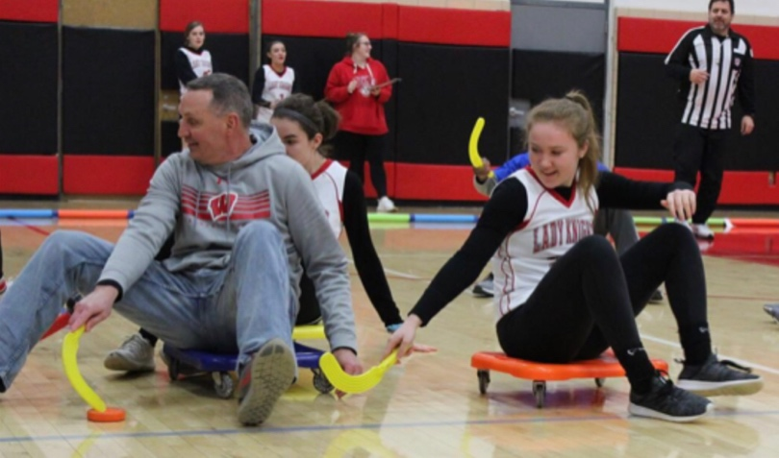
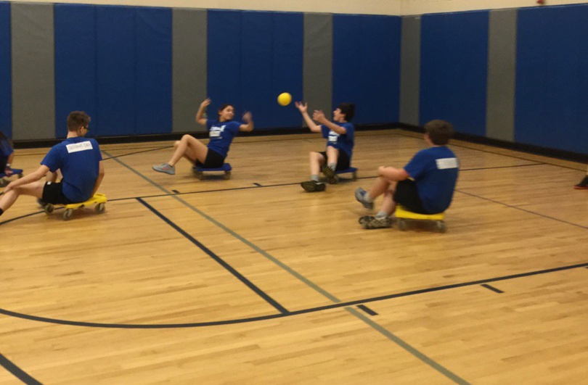
Integrating Disability Sport Units into the General Physical Education Curriculum

Jacob Schafer
Graduate Project
University of Wisconsin-La Crosse

Table of Contents
Related Research…………………………………………………………………...3
Benefits……………………………………………………………………………..6
How to Introduce a Disability Sports Curriculum …………….…………………...9
Lesson Plans………………………………………………………………..9
Goalball…………………………………………………………….
Scooter Handball……………………………………………………
Scooter Hockey……………………………………………………
Sit Volleyball………………………………………………………
Considerations……………………………………………………………..
Class size………………………………………………………….
Equipment……………………………………………………………
Trust and Acceptance………………………………………………
Safety………………………………………………………………..
Resources……………………………………………………………………………
References…………………………………………………………………………….

Related Research
No matter the culture, race, economic status, there is always a universal bond with children when participating in sports. “Sport, to include disability sport, can be taught to students with and without disabilities in your physical education classes” to further strengthen the bond and promote inclusion (Davis, 2019). Disability sports can be a useful method for creating an equal playing field and reducing prejudice in students with disabilities.
Reverse inclusion in a physical education (PE) setting is bringing Adapted Physical Education (APE) students into a General PE setting. If a class is playing traditional basketball for instance and a child in a wheelchair is in the class, traditional basketball put that child at a disadvantage. But if you put everyone in a wheelchair or scooter, now that child is included with their peers. Inclusive education, which is a philosophy that supports and celebrates diversity through the active participation of all students in the school culture can be integrated through disability sports (Kugelmass, 2004). The implementation of wheelchair basketball, goalball, sit-volleyball, and scooter hockey as disability sports included into the general PE curriculum afforded the opportunity to shape students’ perceptions of disability sport (Greiner, 2014). Students with disabilities are typically not afforded the same opportunity as their typically developing peers in relation to sport participation. As Hehir (2007) states, “The disability sports have the potential to transform the way in which skill-based competencies are evaluated by exposing children to sports played by individuals with limited physical functioning. For example, drawing comparisons between sitting volleyball and traditional volleyball raises questions that can challenge myths associated with ableism by highlighting the performative and tactical skills needed for success.”
The primary focus for a disability sport unit is to focus on the affective domain and demonstrating respect for individuals who are different from you whether that be disabilities, motor performance, physical capabilities, race, economic status, gender, or something else. This focus on the affective domain helps students develop understanding and empathy for individuals with disabilities because students have played a sport they wouldn’t normally play because of the abilities they have regularly (Greiner, 2014).
In a study of 178 students, the experimental group, or the group that received the disability sport program showed a positive result when it came to the possibility of including someone with a disability into their class (Panagiotou, 2008). The students that did not receive the disability sport program did not have a different opinion when asked about individuals with disabilities. Students who are presented with an opportunity to shape or change their thinking about a certain topic are more likely to believe something different than if they’re not exposed. Ability in PE is often looked as the physical intelligence of a person (Evans, 2004). When a young student views someone unable to perform a certain task to the same level as typically developing peers, it often creates a negative attitude towards other people with a disability (Evans, 2004).
Disability sports help shape the shift in attitude of acceptance of students with disabilities because most students are not afforded the opportunity to interact with someone with a disabilities through a positive relationship. If designed improperly, the curriculum will focus on what individuals with disabilities cannot do rather than what they are able to perform (Greiner, 2013). This is not about simulating activities to force students to see what it’s like to have a disability. Everyone has the opportunity to enjoy playing a disability sport, even if they are a typically developing person. The curriculum is a fine balance between discovering some of the issues that arise as a result of the disability and finding different ways to be active and find enjoyment in new activities (Greiner, 2013).
The use of videos introducing an disability sport or showing Paralympic athletes compete at the elite level of play helped students understand how similar they are to someone with a disability or a disabled athlete. Students realized that playing a different sport doesn’t make you worse as a person than someone, just different (Greiner, 2013). In addition to that, the time that an athlete with a disability takes to develop skill and master the sport is no different than an able bodied athlete trying to master their own specific sport. As a fifth-grade student put it, “I used to think people with disabilities were a little bit disadvantaged, but now that I have played some of the sports, I think they are just like you and me” (Greiner, 2013). The students came to understand what the opportunities of a person with a disability are and were more supportive of the notion of including students with disabilities into their classes.

Benefits
As a student, the first time I was exposed to adapted sport or sport for students with disabilities was in college. Every student needs to be aware of the opportunities that individuals with disabilities have through disability sport. The earlier a student is presented with modified sports or sports designed for a specific population, the more likely they’ll develop positive attitudes towards individuals with disabilities (Godeau, 2010).
Students who participated in disability activities, or had the opportunity to use equipment used in disability sport showed higher results of acceptance for individuals with disabilities than they previously demonstrated (Panagiotou, 2008). Increasing the opportunities for students to explore experiences different than their own helps empathize with those whose “normal” is that student’s “experience.”
Block (2007) noted that the change in students’ attitudes had to do with the experience of playing disability sport. Students aren’t aware of what capabilities other people have if they’ve not gone through a similar experience. The basis of Greiner’s (2014) research study was to assess the effectiveness of a disability sport unit in shaping perceptions of disability. Students were interviewed pre and post unit answering questions about what disability means and the capabilities of individuals with disabilities. Students participated in wheelchair basketball, goalball, scooter hockey, and sitting volleyball. By the end of the unit in Greiner’s (2014) research, the fourth graders still had a medical model of disability while the fifth graders were able to see different ways people with disabilities could be successful in sport.
Sean and Kara participated as teachers in Greiner’s (2014) research. Sean had poor experience when working with students with disabilities, so in this regard his thoughts to the usefulness of introducing disability sport was low and the unit would be uninteresting. Kara, who had experience working with a disabled population, was excited about implementing the unit and activities because she felt confident about teaching it. Sean ended up enjoying the unit and the activities very much, watching the students learn new skills in the same way he was learning new skills. It was the very opposite of uninteresting (Greiner, 2014). When students are introduced to something unfamiliar to them, in this case an adapted sport setting, they have an opportunity to change their attitudes (D’Andrea, 2019). As seen with the fifth graders, their attitude shifted dramatically (Greiner, 2014).
Students with disabilities also benefit from the implementation of disability sport into the curriculum model. The sports played are designed to be played by individuals with disabilities, and there is a more prominent focus on inclusivity rather than achievement (Godeau, 2010). Students are focused on the abilities of other students instead of the limitations they have. For example, a student in a wheelchair has an obvious difference than someone because of the wheelchair, but in a sport such as goalball, everyone is oblivious to everyone else because there is no sight. This can also be seen in sitting volleyball, where everyone has a slight limitation in their movement patterns.
A second benefit for students with disabilities is the interpersonal connections built between students. In Greiner’s (2013) research, there was a focus of cognitive and affective domains in association to the psychomotor one as well. Students without disabilities are thinking on a higher level as to what full inclusion looks like and have the opportunity to connect beyond the surface level with students with disabilities. Partnerships are formed and authentic connections are built because building those relationships are taught through the curriculum model. Students are given the opportunity to connect, instructed specifically how to connect, and experience the connection with someone who may be seen as “different.”
My website is designed for general physical education teachers who have the desire to implement modified or adapted sports into their classroom. The targeted age is 4th-7th graders, but especially the late elementary students because most elementary schools have access to scooters while middle schools commonly don’t. Students need to be continually introduced to new opportunities and ways to be physically active. Introducing adapted sports into the curriculum helps introduce those opportunities students may not have had in the past.

How to Introduce a Disability Sports Curriculum
As with introducing any new sport unit, there needs to be motive involved. The purpose for introducing students to a disability sports curriculum is for them to interact with each other all on a level playing field and gain understanding for what it’s like to play disability sports. The more variety of activities a student is able to engage with, the more physically literate they’ll be by the time they leave high school. The more opportunities students have to engage with new material, the more likely they are to discover something they’re either very good at or very passionate about. A student might discover that they really enjoy playing disability sports and seek out opportunities in the community to play in an Adapted Sports League, like wheelchair basketball.
The primary focus of the Disability Sports Curriculum is very heavy on the affective domain. A primary goal is for students to connect with one another beyond the achievement side of sports, and focus on everyone’s ability rather than limitations a person has. How can students as a cohesive group, come together and have fun playing a new or modified sport? The following lessons provide activities for students to discover what it’s like to play disability sports and use critical thinking for being a positive teammate and gain understanding for acceptance of others who are different than themselves.

Lesson plans
Goalball
Physical Education Plan
Jake Schafer  Disability Sport Unit  Goalball  Lesson Number: 1 | Equipment Needs:  1 pair of eyeshades or similar for every student  At least 50 poly spots/small squishy balls/fish/frogs, etc.  At least 20 medium gator balls  8+long jump ropes
National Standards and Grade Level Outcomes:  Exhibits personal responsibility by using appropriate etiquette, demonstrating respect for facilities and exhibiting safe behaviors. (S4.M1.6)  Cooperates with a small group of classmates during adventure activi- ties, game play or team-building activities. (S4.M5.6) | Student Learning Objectives and Assessments:  1) SWBAT communicate with a partner who is blindfolded in order to move them safely around the gym during a modified activity.  2) SWBAT move safely (arms out) and traveling at a safe speed during modified activity time.  3) SWBAT compliment or shout-out classmates at the end of the class.

Time (min) | Task Details | Performance Cues  (Teacher Actions + safety reminders) | Organization
10 min | Introduction to Goalball:  Play clip of Goalball  0:00-5:10  https://www.youtube.com/watch?v=3vXLpcdtagQ  and  https://www.youtube.com/watch?v=du5doesduIw (Whole video)  Discussion questions after the video:  - What do you notice about all the athletes? What do you notice about the physical abilities of the athletes compared to one another? Compared to you?  - What kind of disability do you think someone has if they’re playing goalball and why?  - What skills are required in order to play the sport? What other skills in other sports can be used in order to be more successful in goalball?  Goal for the day for the class:  Be on the lookout today for a classmate who’s demonstrating positive sportspersonship, acceptance, or making the learning environment inclusive. Shout-outs at the end. | We’re going to start a disability sports unit. We’re going to play goalball, a sport designed for the visually impaired.  Play video clip.  We’ll discuss full rules when we move into gameplay.  Go over discussion questions | Students gathered around projector screen
4 min | Introduction to Blind Activities:  Safety:  We will be doing activities in which we are blind to our surroundings, either individually, or in partnerships (1 blind, 1 seeing partner). This is to simulate what it is like to have a visual impairment. It is expected that each of you are being safe.  What do you think are examples of being safe when you can’t see?  Potential Answers: (Traveling at a slow speed, being intentional about the learning activity, not injuring your partner like running them into a wall, arms out while traveling)  What do you think will happen if you are not being safe?  Answer: (You will be sitting out.)  Why will you sit out? (If you’re unsafe while blind) |  | 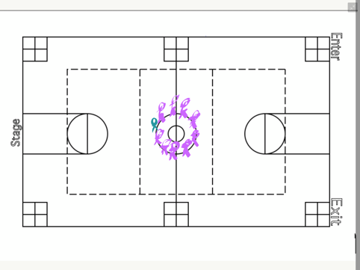
8 min | Blind activity 1: Minefield  In partners, students try to navigate an area (about 30 foot diameter circle-using jump ropes) full of random objects serving as obstacles. The objective is for one partner to guide the other blindfolded partner across  the minefield. Once the partner has reached the other side, they turn around and make their way back, avoiding obstacles or other people in the minefield.  Round 1: Partners may use any the entire vocabulary to guide the person navigating the minefield.  Round 2: Partners may use only 3 words in assisting their partner. (Partners start from a new starting position).  Debrief:  - What challenges did you face from the first round compared to the second  - How did you feel, not knowing your surroundings? | Safety: Obstacles should be flat on the floor, not able to cause harm if someone steps awkwardly on it. (Small squishy balls or poly spots work best). | 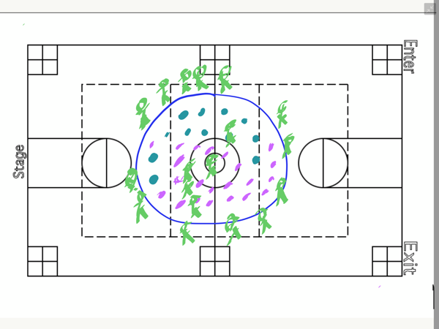
10 min | Tank:  In the same partnerships, one student will remain blindfolded. The other student will guide them around the gym completing the following objective:  The blind athlete is a tank but needs ammunition. The navigator (seeing athlete) will guide them to ammunition (gator balls) to pick up and give the “Fire” command” when another tank is in range.  If you’re the tank or the navigator and you get hit, switch roles with your partner.  Both navigator and tank may attempt to dodge the ball.  Role of the navigator: You may only instruct the tank where to go. You may not handle any of the equipment. The tank must pick up and release the acquired ammunition. | Safety: Do tanks move fast or slow? (Slow) Tanks should be moving at a similar pace for this activity.  Eyeshades should completely block the sight for the tank. | 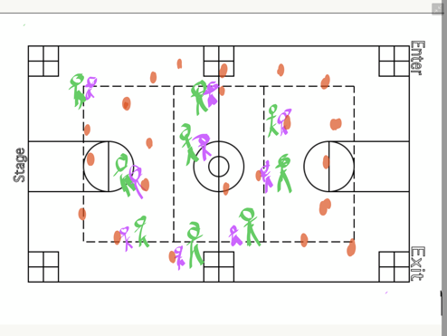
3 min | Debrief:  - What did you find most challenging about the activities today?  - How did you rely on other senses/other people to guide you in Tank?  - What would’ve changed if you had been able to see during the activities?  Shout outs: Who can shout out a classmate for demonstrating positive sportspersonship sometime during class?

Physical Education Plan
Jake Schafer  Disability Sport Unit  Goalball  Lesson Number: 2 | Equipment Needs:  1 pair of eyeshades for every student  1 goalball or basketball per every 2 students  3 mini goalball courts (marked using jump ropes taped to the floor)  Multi-color poly spots (1set of 4 per student)  Lots of jump ropes and tape to make Goalball courts
National Standards and Grade Level Outcomes:  Demonstrates a mature throwing  pattern for a modified target game  such as bowling, bocce or horseshoes. (S1.M.18.6)  Exhibits personal responsibility by using appropriate etiquette, demonstrating respect for facilities and exhibiting safe behaviors. (S4.M1.6) | Student Learning Objectives and Assessments:  1) SWBAT demonstrate a proper rolling technique during practice tasks.  2) SWBAT communicate with a partner while blindfolded.  3) SWBAT compliment or shout-out classmates at the end of the class.

Time (min) | Task Details | Performance Cues  (Teacher Actions + safety reminders) | Organization
2 min. | Review previous material:  Yesterday we started our Goalball unit, a sport designed for the visually impaired. When we were blind yesterday, what other senses did we rely on and how did we rely on them?  Potential Answers:  Touch: Using feet/hands to feel where we are (also called vestibular)  Sound: Hearing where we are in relation to other people. Using voices to communicate, talking through what we’re visualizing
3 min | Introduction to the Goalball court:  There are 3 goalball courts for us to work on today. Given that athletes are visually impaired, they use their sense of touch in order to know where they are on the court. There are a couple of different lines we need to know on the court.  End line: This line is the front line of the goal, if the ball is beyond this point, a goal has been scored.  Team area: There are 3 positions in goalball: Left, Middle, Right. One person lays at each position, there are marker lines indicating those 3 positions.  The front of the team area line is the point at which you cannot bowl the ball beyond, like the foul line in bowling.  The other lines on the court we will cover once we get into gameplay.  When I say go, stand on a left team area line.  When I say go, stand on an end zone line.  When I say go, stand on a right team area line.  When I say go, stand on a middle team area line.  When I say go, stand on a front team area line. | Visual and verbal demonstration (standing on actual lines as you point out what each line is) | 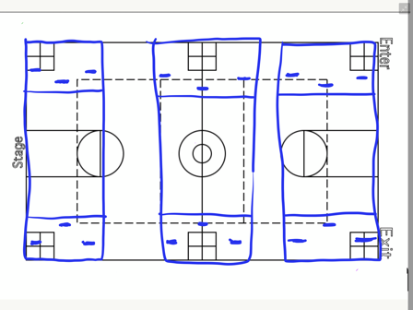
6 min | Diving Technique:  We’re going to work on diving, firstly without eye-shades for safety. If I’m on the left side of the court, which direction will I dive in order to save a goal? (I will dive to my right).  If I’m on the right side of the court, which direction will I dive?  If I’m in the middle, which side will I dive? (I’ll just kind of stay put)  When I dive, my legs extend and so does my right arm. My left arm moves up to protect my face from being hit. Where does my left arm go? Why?  When I say go, everyone needs to find their own open space, either on a team area line, or another space somewhere in the gym. When I clap once, that’s an indication to dive. When I clap twice, we’ll reset. What happens when I clap once?  Clap twice? | Check for understanding during instructions.  Remind students that if they cannot be safe during activities than they will lose out on opportunities to participate.  When calling out dives, start with diving to the right, diving to the left, and staying put.  Cues: Be as long as possible, protect your face | 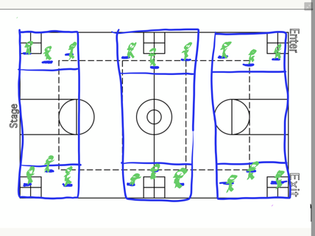
6 min | Rolling technique/Practice:  The motion of rolling a goalball is similar to that of bowling, except there are no finger holes. When we’re bowling we are focused on accuracy and placement of scoring goals. This is not about how hard you can bowl. If you are bowling at a speed that is unsafe, you will be reminded once, and then removed from the activity.  Why do you think I want you to bowl at a safe speed?  The ball should be rolling from the time it leaves your hand. There will be no balls bouncing. Are we clear?  When I say “Go” I need you to get a partner and one goalball or basketball for the two of you. We will start the blue poly spots and move our way backwards towards the red poly spots. (One poly spot per minute) | Safety: If students are struggling to come Think about defense and not being able to see | 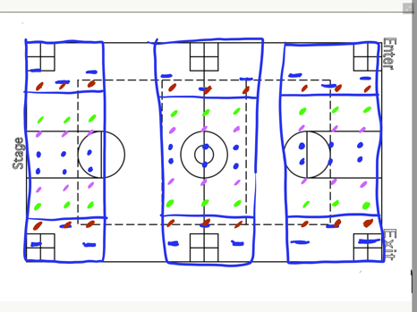
6 min | Bowling to targets:  Now that we understand how to bowl, we’re going to be focusing on bowling to targets. There are different targets set up around the gym. When we are bowling, all bowlers will stand on a green poly spot and bowl towards the cones nearest to them. You are not required to wear your eye shades when bowling, but may if you would like a challenge.  Remember that balls are rolling, not bouncing.  If we are moving from station to station, please do not wear your eye shades for safety. | Safety: Remind students that if they cannot follow standard safety procedures they will be removed from activities. | 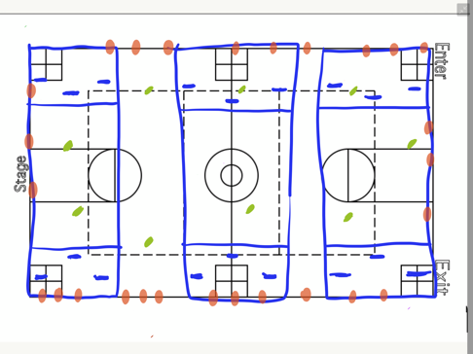
8 min | Diving and Defending bowls:  Our last activity for the day is diving and defending bowls. With your partner, one person will stand on the blue poly spot, the other on the red. You will alternate being the “Bowler” and the “Defender.” You may move your defender a little bit to the left or to the right, but every bowl should be defendable.  Are balls bouncing or rolling? (Rolling). | Safety: Remind students that if they cannot follow standard safety procedures they will be removed from activities. | 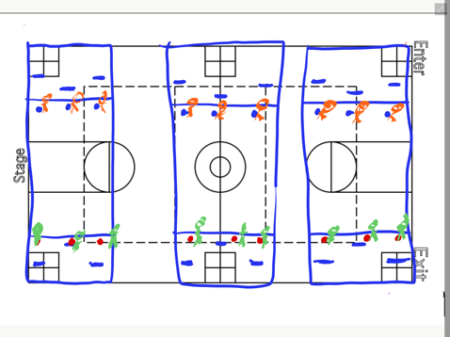
4 min | Debrief:  - When we’re diving, which arm do we use to cover our face?  - If we’re on the left position, which direction do we dive?  - What strategies will you use when you’re using eyeshades in upcoming classes compared to currently when you’re able to use your sight?  Shout outs: Who can shout out a classmate for demonstrating positive sportspersonship sometime during class?

Physical Education Plan
Jake Schafer  Disability Sport Unit  Sport: Goalball  Lesson Number: 3 | Equipment Needs:  1 pair of eyeshades for every student  1 goalball or basketball per every 2 students (Goalballs are preferred)  Lots of jump ropes and tape to make Goalball courts (3)
National Standards and Grade Level Outcomes:  Reduces offensive options for opponents by returning to home position. (S2.M8.6)  Cooperates with a small group of classmates during adventure activities, game play or team-building activities. (S4.M5.6) | Student Learning Objectives and Assessments:  1) SWBAT demonstrate a safe and proper dive for defending the goal in goalball practice tasks.  2) SWBAT pass and receive a goalball to a partner while blindfolded.  3) SWBAT compliment or shout-out classmates at the end of the class.

Time (min) | Task Details | Performance Cues  (Teacher Actions + safety reminders) | Organization
3 min | Review Previous Material:  When I say “Go” I need you to stand up and find one of the end-lines on a goalball court. “Go.”  Now move to the front line.  Side line.  One of the goalie lines.  When I say “Go” show me how you’ll dive. Which hand goes up to cover your face? (Left.) Go!  Find a new goalie mark. And Dive!  Show me the bowling motion. Imagine we have a ball in our hands, which foot steps first? (Opposite). If I’m a right-handed bowler, my foot pattern is what? Right-Left-Right or Left-right-left? (L-R-L)  Where do I want to target? (Between the goalies). | Safety: Remind students that if they cannot follow standard safety procedures they will be removed from activities.  Which hand goes up to cover your face?
2 min | Introduction into Full court Goalball:  Today we’ll be moving into a full goalball game. Today we will not be wearing our eye shades to start off but will build into that.  Full court goalball is a quiet sport. There should be minimal sounds coming from anyone, and court orientation is important. Why do we think it’s important to know where you are on the court?  Potential Answers: Safety (not bumping into each other, being able to defend our goal, offensive awareness (knowing where you are in relationship to the other team’s goal)  Another component is communication. Why do we need to communicate?  Goalball is about defense and offense by way of bowling to a target. We’re going to warm up today with bowling, diving, and defense. | Safety: When we dive, which hand covers our face?
5 min | Bowling, Diving, Defense Diving and Defending bowls:  Our first activity for the day is diving and defending bowls. With your partner, one person will stand on the blue poly spot, the other on the red. You will alternate being the “Bowler” and the “Defender.” You may move your defender a little bit to the left or to the right, but every bowl should be defendable.  Are balls bouncing or rolling? (Rolling). | Safety: Remind students that if they cannot follow standard safety procedures they will be removed from activities. | 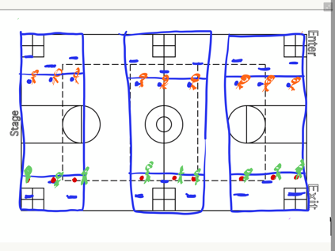
6 min | Bowling, Diving, Defense (Eyeshades)  Our next activity for the day is the same activity, except now you will be required to use your eye shades when defending. When you are bowling, please remove your eyeshades so you are “On-target” with your bowls. Remember to keep bowls safe and your partner should be able to block the ball without moving too far. | Reminder of talking when someone else is talking: Will it be easier to understand if you cannot hear my instructions? When I’m talking there should truly be no one else talking.  Safety: Which hand goes up to cover your face? (Left hand)
3 min | Finding court orientation:  Still wearing their eyeshades, students will move from one court position to the next, starting on the left court position, finding their mark and moving to the middle position. After they find the middle position, they move to the far right mark. This is to help students orient themselves on the court. Once a student has reached the far right mark, they’ll stand up walk off the court (removing their eyeshades) and repeating the process. | Reminder of talking when someone else is talking: Will it be easier to understand if you cannot hear my instructions? When I’m talking there should truly be no one else talking. | 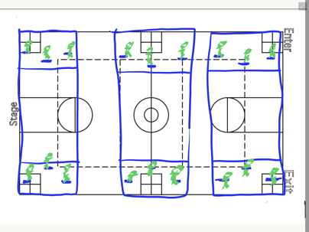
3 min | Full Court Rules:  Please remove your eyeshades for instruction.  When you are bowling, what line can you not cross?  You must rotate the bowl on your team. You cannot bowl 2 times in a row.  Goalball is a quiet sport. There should be minimal sounds. The only noise should be from the ball rolling (not bouncing) on the court.  If a goal is scored, the person off the court will grab the ball and set it in front of the left teammate. The which teammate? | Safety: Remind students that if they cannot follow standard safety procedures they will be removed from activities. (Bouncing the ball, bowling at high speeds).  Some students may be asked to bowl with their non-dominant hand instead of their dominant one.  Cover your face with which hand?
10 min | Goalball: (Eyeshades optional)  In teams of 4, students play goalball. 3 members of the team are on the court at a time. Every 2:30, a mandatory rotate is called, allowing everyone on the team to have equal playing time at each position for the duration of the activity. | Safety: Ensure that students aren’t making unnecessary noises.  Safety: Remind students that if they cannot follow standard safety procedures they will be removed from activities. | 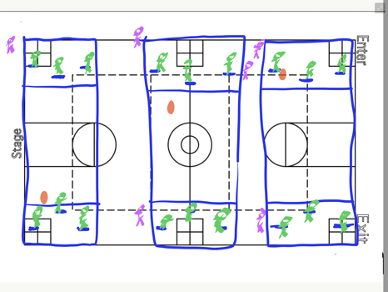
3 min | Debrief  - For those who chose to leave your eyeshades on, what did you notice about the activity?  - For those who chose to leave your eyeshades off, what did you notice about the activity?  - How did you rely on different senses throughout the lesson today?  Shout outs: Who can shout out a classmate for demonstrating positive sportspersonship sometime during class?

Physical Education Plan
Jake Schafer  Disability Sport Unit  Sport: Goalball  Lesson Number: 4 | Equipment Needs:  1 pair of eyeshades for every student  3 goalballs  Lots of jump ropes and tape to make Goalball courts (3)
National Standards and Grade Level Outcomes:  Identifies the rules and etiquette for physical activities, games and dance activities. (S4.M6.6)\  Reduces open space on defense by making the body larger and reducing passing angles. (S2.M4.6) | Student Learning Objectives and Assessments:  1) SWBAT reduce open space by defending a goal  2) SWBAT pass the ball to a teammate during gameplay without using verbal communication.  3) SWBAT compliment or shout-out classmates at the end of the class.

Time (min) | Task Details | Performance Cues  (Teacher Actions + safety reminders) | Organization
3 min | Review Previous Material:  Yesterday we worked on court orientation, communication as a team, bowling, and played our first goalball game without eye shades. Today we are going to be wearing eye shades for the majority of the time. When I say “Go” I need you to get into your teams of 4 from yesterday and find an open court. Remember the rotation. If you start on the left, where do you go? (Middle). Where does middle go? (Right). Where does right go? (Off). What’s the role of the person off? (Grab the ball if a goal is scored or a side-out occurs and place the ball in front of the left teammate)
9 min | Goalball: (Eyeshades required)  In teams of 4, students play goalball. 3 members of the team are on the court at a time. Every 2:20, a mandatory rotate is called, allowing everyone on the team to have equal playing time at each position for the duration of the activity.  Rotation: Every team except one (designate) will move one court to their right. Call out rotation, and teams may remove their eye shades to travel from one court to the next for safety. | Safety: Ensure that students aren’t making unnecessary noises.  Safety: Remind students that if they cannot follow standard safety procedures they will be removed from activities. | 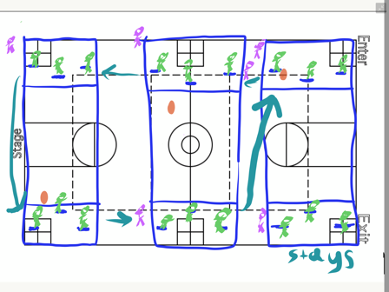
9 min | Goalball: (Eyeshades required)  In teams of 4, students play goalball. 3 members of the team are on the court at a time. Every 2:20, a mandatory rotate is called, allowing everyone on the team to have equal playing time at each position for the duration of the activity.  Rotation: Every team except one (designate) will move one court to their right. Call out rotation, and teams may remove their eye shades to travel from one court to the next for safety. | Safety: Ensure that students aren’t making unnecessary noises.  Safety: Remind students that if they cannot follow standard safety procedures they will be removed from activities.
9 min | Goalball: (Eyeshades required)  In teams of 4, students play goalball. 3 members of the team are on the court at a time. Every 2:20, a mandatory rotate is called, allowing everyone on the team to have equal playing time at each position for the duration of the activity. | Safety: Ensure that students aren’t making unnecessary noises.  Safety: Remind students that if they cannot follow standard safety procedures they will be removed from activities. | 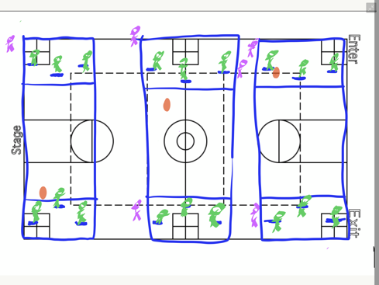
5 min | Final Assessment/Debrief:  - What was the easiest thing for you during the unit?  - What was the hardest thing for you during the unit?  - How can you use your experience playing goalball and other visual impairment activities in the future?  Shout outs: Who can shout out a classmate for demonstrating positive sportspersonship sometime during class?

Scooter Handball
Physical Education Plan
Jake Schafer  Disability Sport Unit  Scooter Handball  Lesson Number: 1 | Equipment Needs:  1 scooter for every child  1 medium gopher ball for every 2 children  4 cones indicating lines to stand on  4 cones per group of 3 students  Video projector with computer accessible to the internet
National Standards and Grade Level Outcomes:  Throws, while stationary, a leading pass to a moving receiver. (S1.M5.6)  Accepts differences among classmates in physical development, maturation and varying skill levels by providing encouragement and positive feedback. (S4.M4.6) | Student Learning Objectives and Assessments:  - SWBAT demonstrate a mature overhand throwing pattern from the sitting position following the cues Point and follow through during a throwing activity.  - SWBAT explain how their throwing motion was altered when sitting on a scooter during a think-pair-share.  - SWBAT compliment or shout-out classmates at the end of the class.  Assessment: Teacher observation on cognitive domain (Students explaining how their throwing motion was altered from standing to sitting).

Time (min) | Task Details | Performance Cues  (Teacher Actions + safety reminders) | Organization
10 min | Introduction to Scooter Handball:  Play clip of Wheelchair Rugby  https://youtu.be/Pmp5tUCVWj4  Start at 8:00 and go until 14:15  Discussion questions after the video:  - What do you notice about all the athletes? What do you notice about the physical abilities of the athletes compared to one another? Compared to you?  - What kind of disability do you think someone has if they’re playing wheelchair rugby and why?  - What skills are required in order to play the sport? What other skills in other sports can be used in order to be more successful in wheelchair rugby?  Goal for the day for the class:  Be on the lookout today for a classmate who’s demonstrating positive sportspersonship, acceptance, or making the learning environment inclusive. Shout-outs at the end. | We’re going to start a disability sports unit. We’re going to play scooter handball, a modification based off of wheelchair rugby as played in the Paralympic Games.  Play video clip.  We’ll discuss full rules when we move into gameplay.  Go over discussion questions | Students gathered around projector screen
4 min | Standard Throwing and Catching (Standing up):  In partners, students will practice throwing and catching at a distance 10-15 feet. As students become more comfortable, they may back up to a maximum distance of 20 feet.  If students aren’t comfortable throwing at a further distance with both their right and left hands, they may step to a closer distance (5 feet). | When I say Go, I need one partner to stand on the black line and the other partner to get a ball and stand across from them on the blue line.  Check for understanding.  Go.  When we are throwing, what cues do we need to follow? Step-Point-Release-follow through.  Be sure that we are throwing with both our right and left hands.  When we are catching what cues do we need to follow? Arms out-hands apart-catch away from the body. | 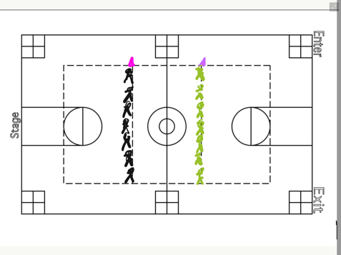
4 min | Modified (Stationary) Throwing and Catching  Students on one line move one person to the left, ensuring that everyone is working with a different person this round.  Students are still at a distance of 10 feet throwing with both their right and left hands, but not stepping in opposition. Both feet should be on the line their standing on, not one in front of the other.  Distance is the modification. Depending on the success of the student, they may either back up or step closer together. When they are doing this, be sure that their feet are stationary before they are throwing the ball. | As we progress with throwing and catching in scooter handball, we will be taking away your “step.” Now you must throw with both feet stationary, side by side or in a jumping jack position.  It is important that we are throwing with both our right and our left hands. Be sure that we are focusing especially on the follow-through aspect of the throw.  Our catching position remains the same, but our goal now is to not move our feet. | 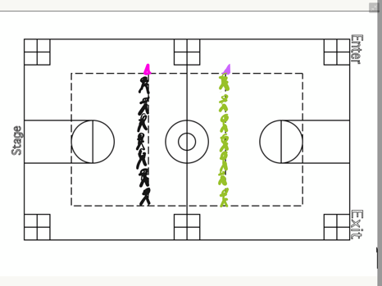
2 min | Scooter Safety  When we are using scooters, you will only be sitting on your bottom.  Your eyes need to be looking in the direction in which you are traveling.  If you are kneeling, standing, or belly-flopping on your scooter, you will lose your scooter for the day. Is this clear? | When I say go, I need the partner without the ball to grab 2 scooters, one for you and one for your partner.  What are you doing when I say go?
3 min | Sitting Throwing and Catching  We are now going to be throwing while seated on our scooters. We are still following the upper-body throwing progression of arm back, point, release and follow through. Our eyes need to be on our target. | When I say go I need the partner with the ball to jump as high as they can while the other partner gets scooters for them and their partner. What are you doing when I say go? Go. | 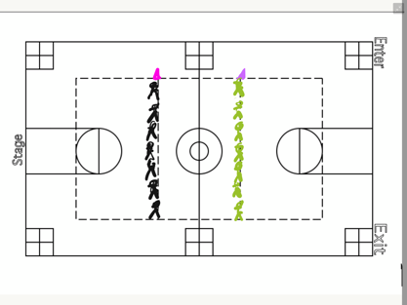
5 min | Scooter movement activities:  In teams of 2, students will weave in and out of cones, (slalom style) going first round forwards and then second round backwards through the sets of cones/spots. They will continue alternating forwards/backwards until time is called.  Divide half the class and have teams start on each of the basketball baselines, moving towards half court and then back towards their partners. Once they reach their partner, their partner will begin the slalom course.  Round 1: Slow: Just like we were to be walking  Round 2 and following: You may move at a speed walking pace. This is a little faster while still maintaining control of your scooter. | When I say Go, I need one partner to take both scooters to a cone on one of the basketball baselines. The other partner is going to come grab 8 cones or spots from the pile and line them up as I have in front of their partner’s cone. | 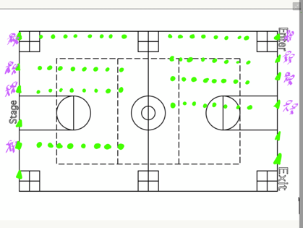
4 min | Think-Pair-Share:  - How was the throwing motion altered when you took a seat instead of throwing? How did you adjust throughout class?  - What changes did you have to make from normally standing to now moving on a scooter, especially with offensive and defensive tactics?  Stretches: Hip flexor stretches, quads, hamstrings, shoulder and arms.  Shout outs: Who can shout out a classmate for demonstrating positive sportspersonship sometime during class? | When I say go, I need balls back in the red bag, scooters back in the hoops you found them and meet me around the middle circle.  Check for understanding. Go.

Physical Education Plan
Jake Schafer  Disability Sport Unit  Scooter Handball  Lesson Number: 2 | Equipment Needs:  1 scooter for every child  1 Handball (or medium gopher ball) for every 2 children  2 cones indicating lines to stand on  4 cones per group of 3 students, these cones will also be used for end zone markers (4 of the same color preferred)
National Standards and Grade Level Outcomes:  Performs pivots, fakes and jab steps designed to create open space during practice tasks. (S1.M6.6)  Creates open space by using locomotor movements (e.g., walking, running, jumping and landing) in combination with movement (e.g., varying pathways; change of speed, direction or pace). (S2.M1.6)  Exhibits personal responsibility by using appropriate etiquette, demonstrating respect for facilities and exhibiting safe behaviors. (S4.M1.6) | Student Learning Objectives and Assessments:  1) SWBAT demonstrate offensive and defensive strategies in 2 on 1 settings, such as moving to open space (offense) and defending open space (defense).  2) SWBAT demonstrate positive interpersonal relationships by asking for a pass and letting a teammate know a pass is coming during a passing activity.  3) SWBAT shout-out a classmate at the end of class, looking out for positive sportspersonship and acceptance of others.

Time (min) | Task Details | Performance Cues  (Teacher Actions + safety reminders) | Organization
2 min | Introduction and review of previous material.  Goal for the day for the class:  Be on the lookout today for a classmate who’s demonstrating positive sportspersonship, acceptance, or making the learning environment inclusive. Shout-outs at the end. | Yesterday we worked on throwing and catching from the seated position. What challenges did we have again? What can we do to make our throws successful? | Everyone meets in the middle of the gym, ready for instruction for the day.
5 min | Scooter activities:  Students will start on one line of the gym and start first facing forward. They must go all the way down and all the way back.  Round 2: Students will be moving backwards, looking at where they’re traveling to avoid any sudden collisions.  Transition into throwing and catching, much like the first lesson.  Each student will need a partner. One partner stands on one line, the other on the opposite. | Safety: Make sure that your eyes are looking where you’re going.  Be sure that you’re moving at a speed that you can control your speed.  When I say Go, I need you to go toe to toe with a partner. The taller partner will grab one ball, the shorter partner grab 2 scooters.  Check for understanding. Go. | 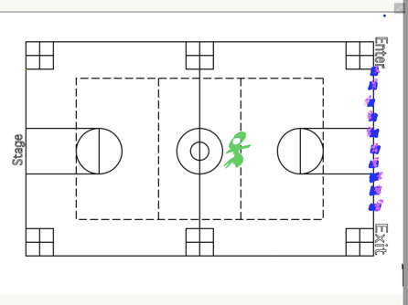
3 min | Sitting Throwing and Catching  Students are now on scooters, their feet in front of them. The closer students are to each other the easier it will be to make successful passes. | Just like we did yesterday, we’re going to be warming up overhand throwing and catching with both arms. Be sure that we are looking at our target and following through.
8 min | Sitting Throwing and Catching in a Line  In a line of 4 students, groups will pass one ball all the way down and all the way back as quickly as they can while making safe, overhand passes.  Once the passes have been completed, each person on the team rotates one spot so each person will take the place in each spot in the line.  If the ball is dropped at any point, it is returned to the starting student. | When I say Go, I need every group to join with one other group. One person from each group will sit on their scooter at the predetermined locations (makes by cones)  Check for understanding.  Go.  When I say Go, each team will attempt in passing their ball all the down and all the way back to the person it started with. Once you’ve completed that, each person on the team rotates one spot towards the blue cone and repeat. | 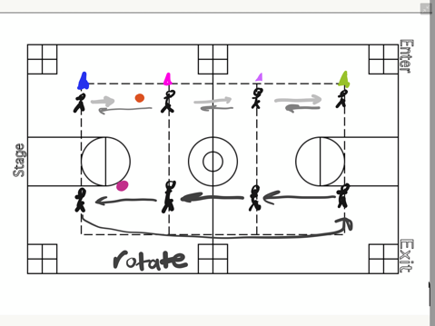
3 min | Transition: I need everyone to meet in the middle circle in 5, 4, 3….  Scooter Handball is an invasion game. This means that one team is trying to score in another team’s territory. What are some examples of this? (Soccer, Handball, Football, Basketball, etc.)  In scooter handball, the objective is similar to that of football. A “try” is achieved when one team passes into the end zone.  Introduction to Offense and Defense:  When someone is on offense, what is their goal? (Score. How? Pass the ball into the end zone)  When someone is on defense, what is their goal? (Prevent the passing of the ball into the end zone).  What does good offense look like? (Moving to open space)  What does good defense look like? (Moving with offender to limit open space) | Countdown  Use students as examples when teaching offense and defense. (The student on the red scooter is on offense, the student on the green scooter is the defender). Where does red go in order to complete a successful pass? Where does green go in order to prevent the pass from occurring? | Students meet in the middle of the gym, waiting further instruction
10 min | 2 on 1s  In groups of 3, 2 students will be on offense and 1 person will be on defense. The person with the ball is the thrower and cannot move. The other person is the receiver and will be covered by the defender. Where the offender moves, the defender moves. Passes must be attempted in 10 seconds or less, and once the pass has been attempted, the receiver becomes the thrower and the defender now moves to the uncovered target. Once the defender is set (ready), the ten seconds start. If the 10 seconds elapse without a throw, it is a turnover and a new person defends.  After 5 attempted passes, a new student defends. Be sure to switch the pinnie so there’s no question at who’s playing defense. Each student should have equal numbers when being a defender.  Students should stay inside of a 12x12 square, dictated by cones. | When I say Go, I need you to find two people with a different color shirt than you. This is your team of 3. One person wear the yellow pinnie (this indicates who is on defense). One ball per group. And sit on your scooters inside a group of 4 cones.  Check for understanding.  What can you do as the receiver in order to get open?  What can you do as the defender in preventing the receiver getting open? | 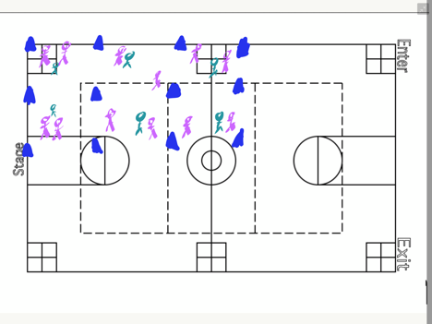
4 min | Discussion Question:  - What did you find a success while working in your teams?  - What was a challenge while working in your team?  Stretches: Hip flexor stretches, quads, hamstrings, shoulder and arms.  Shout outs: Who can shout out a classmate for demonstrating positive sportspersonship sometime during class? | When I say go, I need balls back in the red bag, scooters back in the hoops you found them and meet me around the middle circle.  Check for understanding. Go. | 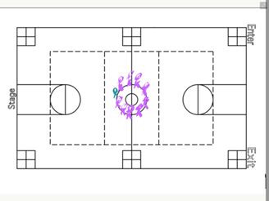

Physical Education Plan
Jake Schafer  Disability Sport Unit  Scooter Handball  Lesson Number: 3 | Equipment Needs:  1 scooter for every child  1 handball (or similar size) for every 2 children  2 cones indicating lines to stand on  4 cones per group of 3 students
National Standards and Grade Level Outcomes:  Passes and receives with hands in combination with locomotor patterns of running and change of direction & speed with competency in invasion games such as basketball, flag football, speedball or team handball. (S1.M4.6)  Creates open space by using the width and length of the field/court on offense. (S2.M3.6)  Demonstrates respect for self and others in activities and games by following the rules, encouraging others and playing in the spirit of the game or activity. (S5.M6.6) | Student Learning Objectives and Assessments:  1) SWBAT demonstrate effective offensive tactics for scoring points during modified gameplay.  2) SWBAT communicate with their team to plan for effective scoring during team-based practice tasks.  3) SWBAT shout-out a classmate at the end of class, looking out for positive sportspersonship, acceptance of others, and playing fairly.

Time (min) | Task Details | Performance Cues  (Teacher Actions + safety reminders) | Organization
2 min | Introduction and review of previous material.  Goal for the day:  Be on the lookout today for a classmate who is demonstrating positive sportspersonship, acceptance, or making the learning environment inclusive. Shout-outs at the end. | Yesterday we worked on throwing and catching from the seated position and then moved into gameplay.  Safety:  When we are on our scooters, we are only on our bottoms. If you are standing, kneeling, or belly flopping you will be done for the day. | Everyone meets in the middle of the gym, ready for instruction for the day.
10 min | 3 on 2s  In groups of 5, 3 students will be on offense and 2 students will be on defense. The person with the ball is the thrower and cannot move. The other person is the receiver and will be covered by the defender. Where the offender moves, the defender moves. Passes must be attempted in 10 seconds or less, and once the pass has been attempted, the receiver becomes the thrower and the defender now moves to the uncovered target. One the defender is set (ready), the ten seconds start.  After 8 attempted passes, one member of the defense moves to the offense, and one member of the offense moves to the defense.  If the 10 seconds elapse without a throw, it is a turnover and a new person defends  Students should stay inside of a 20x20 square, dictated by cones. | When I say go, I need you to get into groups of 5.  Just like before, the side with more people, in this case 3 is the offense, the side with 2 are what? (Defense.)  Your objective is now to complete 8 passes in a row without dropping the ball. Be sure that everyone in your group catches the ball during those 8 passes. | 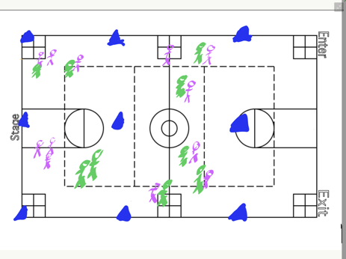
4 min | Introduction into full Scooter Handball:  As we saw in the Scooter Rugby video yesterday, the objective of the game is to what? (Possess the ball inside of the end zone lines).  Handball is more similar to football in that a pass and catch must be the method instead of a roll across the end zone line.  Full Rules:  If you fall off the scooter, you must first get back on your scooter before you possess the ball.  If the ball is loose, it may be picked up by either team, but remember if you fall off your scooter trying to possess the ball, can you hold onto it? (No)  After a score is achieved, the ball is placed at the front of the end zone line, in which the other team will possess the ball in attempt to score.  If a pass is dropped in the end zone, the ball must come back out of the end zone into the regulation field of play before it goes back into the end zone.  If the opposing team possesses the ball in their end zone, they may roll forward to the front edge of their end zone line.  A student guarding the ball holder may count a “Stall” similar to that in Ultimate Frisbee. “Stall 1, Stall 2, Stall 3.” If Stall 10 is reached, a turnover is given. The ball is set down at that spot and the other team assumes possession.  If the ball goes out of bounds, a throw-in similar to basketball or soccer is awarded to the other team. | Demonstrate the falling off the scooter with the students’ help. What does possessing the ball look like? Not look like?  A drop in the end zone? Passing out of the end zone.
10 minutes | Gameplay:  In teams of 4 or 5, students will be playing Scooter Handball following the rules mentioned above. As previously mentioned, if a student is in possession of the ball, they cannot move. Before a score can be marked, everyone on the team must possess the ball. | Teams should be evenly divided based off ability level.  Safety: Gym should be divided into equal playing areas, cones marking the end zone lines with enough room at the back of each end zone that students will not crash into the wall. | 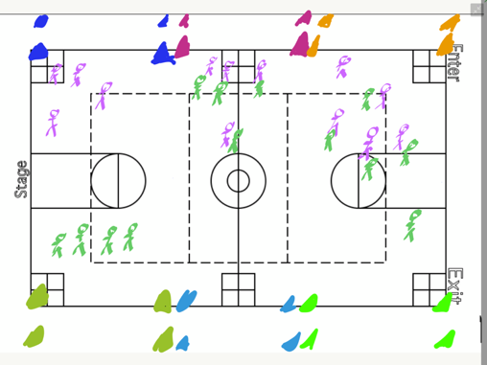
6 minutes | Team Group Time:  Now that students have had an opportunity to play the game, give them an opportunity to work as a team on specific objectives, such as moving into open space, defending an elusive receiver, or throwing and catching. | Every team should be working on a recognizable skill, whether that be offense and defense, throwing with a defender guarding the thrower, etc. | 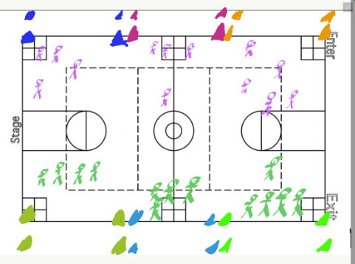
3 min | Discussion Question:  - What did you find a success while working in your teams?  - What role did a physical disability play with your team and how did you overcome that?  Stretches: Hip flexor stretches, quads, hamstrings, shoulder and arms.  Shout outs: Who can shout out a classmate for demonstrating positive sportspersonship sometime during class? | Teacher Actions: Make sure that everyone is following the

Physical Education Plan
Jake Schafer  Disability Sport Unit  Scooter Handball  Lesson Number: 4 | Equipment Needs:  1 scooter for every child  1 handball (or similar size) for every 2 children  2 cones indicating lines to stand on  4 cones per group of 3 students
National Standards and Grade Level Outcomes:  Passes and receives with hands in combination with locomotor patterns of running and change of direction & speed with competency in invasion games such as basketball, flag football, speedball or team handball. (S1.M4.6)  Creates open space by using the width and length of the field/court on offense. (S2.M3.6)  Demonstrates respect for self and others in activities and games by following the rules, encouraging others and playing in the spirit of the game or activity. (S5.M6.6) | Student Learning Objectives and Assessments:  1) SWBAT demonstrate effective offensive tactics for scoring points during modified gameplay.  2) SWBAT communicate with their team to plan for effective scoring during team-based practice tasks.  3) SWBAT shout-out a classmate at the end of class, looking out for positive sportspersonship, acceptance of others, and playing fairly.

Time (min) | Task Details | Performance Cues  (Teacher Actions + safety reminders) | Organization
2 min | Introduction and review of previous material.  Goal for the day:  Be on the lookout today for a classmate who’s demonstrating positive sportspersonship, acceptance, or making the learning environment inclusive. Shout-outs at the end. | Yesterday we worked on throwing and catching from the seated position and then moved into gameplay.  Safety:  When we are on our scooters, we are only on our bottoms. If you are standing or kneeling or belly-flopping you are done for the day | Everyone meets in the middle of the gym, ready for instruction for the day.
2 min | Additional Modifications:  Using notecards for random selection, students will draw an example of a disability and that will be their disability for the class. Examples include:  You can only use your right arm  You can only use your left arm  You can only push with your right leg  You can only push with your left leg  You cannot speak  You can only see out of one eye.  Discussion (Think-Pair-Share):  - How do you think your disability will impact you this class compared to previous classes?  - What are you going to modify or do differently today in order to maintain success with your team?  Transition:  When I say Go, I need you everyone to grab one scooter and meet with your teams as we warm up and get ready for gameplay! | Check for understanding:  What are you doing when I say go? (Grabbing a scooter, warming up with your team)
5 min | Warm-up with your team:  Continuation of yesterday, when you were given the opportunity to work on a specific objective. With the additional stipulations attached, be sure that everyone is following their assigned modifications. Communicate as a team on how you’re going to be successful with everyone’s unique abilities. | Fairness: Please be sure that you are holding yourself accountable for your modification today. Is it fair if I can only use my left arm to catch a ball with my right arm and continue play? No. Admit fault, set the ball down and play results in a turnover. If you can’t speak today in class, don’t.
2 min | Review Rules:  Can we possess a ball if we are off our scooter? (No.)  What happens if we drop a pass in the end zone? (Ball goes back out before it goes back in)  What is a stall count? (Defender counting up on person with ball, forcing a throw before stall 10).  What happens if a ball goes out of bounds? (Throw in by other team)  Where does the ball go after a score or the other team intercepts pass in end zone? (Front end zone line) | Safety:  Should you be making contact with other players’ scooters intentionally? (No.)
6 min | Gameplay:  In teams of 4 or 5, students will be playing Scooter Handball following the rules mentioned above. As previously mentioned, if a student is in possession of the ball, they cannot move. Before a score can be marked, everyone on the team must possess the ball.  Rotation:  If your team is on the east wall, you’re going to rotate one field to the north. If you’re the most north court, you’re going to rotate to the most south court. Ball stays on your field. | Safety:  Gym should be divided into equal playing areas, cones marking the end zone lines with enough room at the back of each end zone that students will not crash into the wall. | 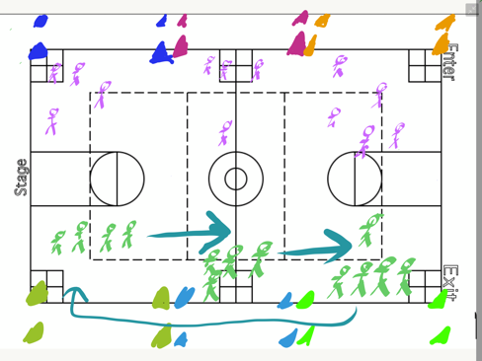
6 min | Continued Gameplay:  In teams of 4 or 5, students will be playing Scooter Handball following the rules mentioned above. As previously mentioned, if a student is in possession of the ball, they cannot move. Before a score can be marked, everyone on the team must possess the ball.  Rotation:  If your team is on the east wall, you’re going to rotate one field to the north. If you’re the most north court, you’re going to rotate to the most south court. Ball stays on your field.
6 min | Continued Gameplay:  In teams of 4 or 5, students will be playing Scooter Handball following the rules mentioned above. As previously mentioned, if a student is in possession of the ball, they cannot move. Before a score can be marked, everyone on the team must possess the ball.  Transition out:  When I say go, I need you to return your scooters back and meet me in the middle circle for our debriefing time. Go! | When I say go, I need balls back in the red bag, scooters back in the hoops you found them and meet me around the middle circle.  Check for understanding. Go.
6 min | Final Discussion Questions (Written)  - What did you notice from the beginning to the end of the unit? What changed and why?  - How did your team make adjustments as new rules and modifications took place? Was this easy, hard?  - Was this experience rewarding to you and if so why? If not, why?  - How might you relate your experience to a person with a disability?  - Shout out someone on a different team who exemplified exceptional sportspersonship? What makes this person fun to be around? Would you want them on your team and why or why not?  Stretches: Hip flexor stretches, quads, hamstrings, shoulder and arms.  Shout outs: Who can shout out a classmate for demonstrating positive sportspersonship sometime during class? | Teacher Actions:  Be sure that students are evenly spaced out and have the necessary writing implements for the assessment.  When you’re Finished:  Discuss with a partner, someone not on your team on the discussion questions. Find similarities between the two of you and discuss the differences.

Scooter Hockey

Physical Education Plan
Jake Schafer  Disability Sport Unit  Sport: Scooter Hockey  Lesson Number: 1 | Equipment Needs:  1 scooter for every child  2 scooter sticks (or hockey blades) for each child  1 tennis ball or puck for every child  40+poly spots or small cones  Video projector with computer accessible to the internet
National Standards and Grade Level Outcomes:  Demonstrates the mature form of the forehand and backhand strokes with a short-handled implement in net games such as paddle ball, pickleball or shorthandled racket tennis. (S1.M14.6)  Identifies the rules and etiquette for physical activities, games and dance activities. (S4.M6.6) | Student Learning Objectives and Assessments:  - SWBAT demonstrate scooter safety by travelling at a controlled speed and looking where they’re travelling during activity time.  - SWBAT explain how their passing motion was altered when sitting on a scooter during a think-pair-share.  - SWBAT compliment or shout-out classmates at the end of the class.

Time (min) | Task Details | Performance Cues  (Teacher Actions + safety reminders) | Organization
10 min | Introduction to Scooter Hockey:  Play clip of Sledge Hockey:  https://www.youtube.com/watch?v=tmFhwcDIzmI  Start at 4:30 and go until 8:05  And https://www.youtube.com/watch?v=LELQQYOwF_s  Discussion Questions after the videos:  - What do you notice about the physicality of the athletes?  - What do you notice about the type of equipment the athletes are using?  - What skills are required to play the sport? What other skills in other sports can be used in order to be successful in sled hockey?  Goal for the day for the class:  Be on the lookout today for a classmate who’s demonstrating positive sportspersonship, acceptance, or making the learning environment inclusive. Shout-outs at the end. | We’re going to start a disability sports unit. We’re going to play scooter hockey, a modification based off of sledge hockey as played in the Paralympic Games.  Play video clip.  We’ll discuss full rules when we move into gameplay.  Go over discussion questions | Students gathered around projector screen.
3 min | Scooter Safety  When we are using scooters, you will only be sitting on your bottom.  Your eyes need to be looking in the direction in which you are traveling.  If you are kneeling, standing, or belly-flopping on your scooter, you will lose your scooter for the day. Is this clear?  Introduce Moving with sticks:  Students will be moving themselves in combination via scooter sticks (or the detached blade of a hockey stick) and their feet. Because sledge hockey you can only travel forwards, students may only travel forward in this sport. | When I say go, I need the partner without the ball to grab 2 scooters, one for you and one for your partner.  What are you doing when I say go? | Everyone in the same position as previous activity
6 min | Scooter movement activities:  In teams of 2, students will weave in and out of cones, (slalom style) going first round forwards and then second round backwards through the sets of cones/spots. They will continue alternating forwards/backwards until time is called.  Divide half the class and have teams start on each of the basketball baselines, moving towards half court and then back towards their partners. Once they reach their partner, their partner will begin the slalom course.  Round 1: Slow: Just like we were to be walking  Round 2 and following: You may move at a speed walking pace. This is a little faster while still maintaining control of your scooter. | When I say Go, I need one partner to take both scooters to a cone on one of the basketball baselines. The other partner is going to come grab 8 cones or spots from the pile and line them up as I have in front of their partner’s cone.
6 min | Scooter movement continued:  Students will be moving around the gym, around the poly spots laid out randomly throughout the gym.  If a student rolls over a poly spot, they must perform 3 Russian Twists (feet off the ground rotate left-right counts as 1).  Balls will be placed on top of dots. Students will try and collect as many balls as they can and return them to their starting position (designated by a hoop or cone). Students may grab one ball, set it on their lap and return to their starting position before they move to a new spot and collect a new ball.  The objective is to avoid other people, or dots. Our eyes need to be up so we know where we are going.  For multiple rounds, balls can be worth a different number of points, and different colored balls can be worth different points to incentivize moving to a specific target. | Safety: When we are travelling, can I move backwards? (No.) | 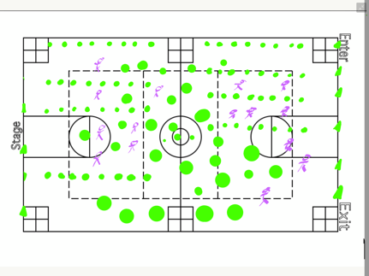
6 min | Passing and Catching  We are now going to be passing with our sticks just like we would be in traditional hockey except we will be seated on our scooters. Our eyes need to be on our target, and we should be passing with both our right and left hand.  When I am passing, my stick needs to be pointed at my partner. When I am catching, remember to absorb the pass, just like you’re catching an egg.  You and your partner will be paired up across from one another. For today, you need to stay on your assigned line. Be sure that you are passing with both your right and left hand, absorbing the ball before you pass. | When I say go I need the partner with the ball to jump as high as they can while the other partner gets sticks for them and their partner. What are you doing when I say go? Go.
4 min | Think-Pair-Share:  - How was the passing and catching motion altered when you took a seat instead of traditional hockey in which you’re standing up?  - What changes did you have to make in order to receive a pass and make a safe pass?  Stretches: Hip flexor stretches, quads, hamstrings, shoulder and arms.  Shout outs: Who can shout out a classmate for demonstrating positive sportspersonship sometime during class?

Physical Education Plan
Jake Schafer  Disability Sport Unit  Scooter Hockey  Lesson Number: 2 | Equipment Needs:  1 scooter for every child  2 scooter sticks (or hockey blades) for each child  1 tennis ball or puck for every child  40+poly spots or small cones  6 hockey goals
National Standards and Grade Level Outcomes:  Shoots on goal with power in a dynamic environment as appropriate to the activity. (S1.M10.6)  Creates open space by using the width and length of the field/court on offense. (S2.M3.6)  Exhibits personal responsibility by using appropriate etiquette, demonstrating respect for facilities and exhibiting safe behaviors. (S4.M1.6) | Student Learning Objectives and Assessments:  - SWBAT demonstrate effective passing while creating open space in practice activities.  - SWBAT score on goal from a variety of distances and angles using both their right and left hands.  - SWBAT shout-out a classmate at the end of class, looking out for positive sportspersonship and acceptance of others.

Time (min) | Task Details | Performance Cues  (Teacher Actions + safety reminders) | Organization
2 min | Introduction and  Review of previous material: Moving on a scooter, receiving a pass.  Goal for the day for the class:  Be on the lookout today for a classmate who’s demonstrating positive sportspersonship, acceptance, or making the learning environment inclusive. Shout-outs at the end. | Yesterday we worked on scooter movement, safety, and passing from the seated position. We’re going to start off today with scooter activities.  When I say go, I need everyone to go toe-to-toe with someone near you. One partner is going to grab 2 scooters, the other partner will grab 2 balls/pucks.  What are you doing when I say go?
10 min | Scooter activities  Round 1: (5 min)  Students will be moving around the gym dribbling and moving with their ball/puck, around the poly spots laid out randomly throughout the gym.  Optional Challenge: If a student rolls over a poly spot, they must perform 3 Russian Twists (feet off the ground rotate left-right counts as 1).  Round 2: 5 min  Shark: One student will be the “shark” and return their ball/puck back to the original bin. The other students will be dribbling as they were before, but if the shark knocks away their ball, and the ball hits a wall, then that student returns their ball and they too, become a shark. After the end of a round, everyone grabs a new ball and the last remaining person becomes the shark for the next round. If needed, 2 sharks may be selected at the beginning.  First shark(s) will be wearing a colored penny. | Safety: When we are travelling, can I move backwards? (No.) | 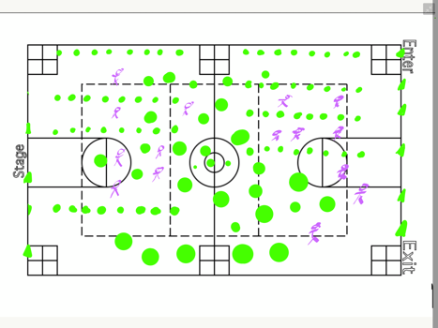
6 min | Passing and Catching  We are now going back to passing and catching like we were yesterday.  1st 3 minutes: Students will be passing to stationary partner. (Partner is sitting on one of the green dots waiting for the pass).  2nd 3 minutes: Student 1 doesn’t have the ball. They are sitting on their green dot and move to the red dot. Student 2 (partner with the ball) passes to the red dot so that the ball and Student 1 arrive at the same time. Student 1 catches (absorbs) the pass and the two students switch roles. (Switch colors as necessary). | We must absorb the pass before we try and pass the puck back to our partner.  Do I need to pass the ball as hard as I can? (No) | 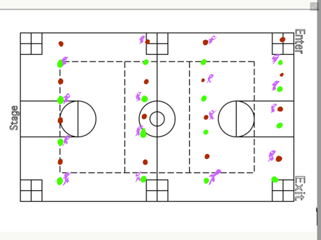
7 minutes | Shooting on Goal  Students will have the opportunity to move around the gym shooting at different goals set out. Poly spots will be set out at varying distances around each goal, allowing students the opportunity to score from both short and long distances, and from different angles.  After a student shoots on goal, they will retrieve their own ball | If someone is retrieving their puck or is in front of the goal, should we be shooting? (No). | 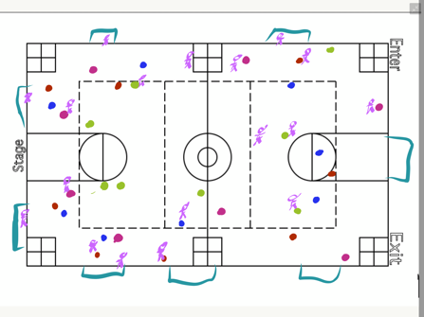
7 minutes | 2 on 1s  In groups of 3, 2 students will be on offense and 1 person will be on defense as dictated by the colored penny. The person with the ball is the passer and cannot move. The other person is the receiver and will be covered by the defender. Where the offender moves, the defender moves. Passes must be attempted in 10 seconds or less, and once the pass has been attempted, the receiver becomes the thrower and the defender now moves to the uncovered target. Once the defender is set (ready), the ten seconds start. If the 10 seconds elapse without a throw, it is a turnover and a new person defends.  After 5 attempted passes, a new student defends. Be sure to switch the pinnie so there’s no question at who’s playing defense. Each student should have equal numbers when being a defender.  Students should stay inside of a 12x12 square, dictated by cones. | When I say Go, I need you to find two people with a different color shirt than you. This is your team of 3. One person wear the yellow penny (this indicates who is on defense). One ball per group. And sit on your scooters inside a group of 4 cones.  Check for understanding.  What can you do as the receiver in order to get open?  What can you do as the defender in preventing the receiver getting open?
3 minutes | Think-Pair-Share:  - How was the passing and catching motion altered when you took a seat instead of traditional hockey in which you’re standing up?  - What changes did you have to make in order to receive a pass and make a safe pass?  Stretches: Hip flexor stretches, quads, hamstrings, shoulder and arms.  Shout outs: Who can shout out a classmate for demonstrating positive sportspersonship sometime during class?

Physical Education Plan
Jake Schafer  Disability Sport Unit  Scooter Hockey  Lesson Number: 3 | Equipment Needs:  1 scooter for every child  2 scooter sticks (or hockey blades) for each child  1 tennis ball or puck for every child  40+poly spots or small cones
National Standards and Grade Level Outcomes:  Demonstrates respect for self and others in activities and games by following the rules, encouraging others and playing in the spirit of the game or activity. (S5.M6.6)  Accepts differences among classmates in physical development, maturation and varying skill levels by providing encouragement and positive feedback. (S4.M4.6)  Identifies open spaces and attempts to strike object into that space. (S2.M10.6) | Student Learning Objectives and Assessments:  - SWBAT demonstrate defensive tactics such as covering open space during modified gameplay  - SWBAT shout-out a classmate at the end of class, looking out for positive sportspersonship and acceptance of others.  - SWBAT score on goal from a variety of distances during activity time.

Time (min) | Task Details | Performance Cues  (Teacher Actions + safety reminders) | Organization
2 min | Introduction and review of previous material:  Offense and Defense (moving to open space), passing and receiving.  Goal for the day for the class:  Be on the lookout today for a classmate who’s demonstrating positive sportspersonship, acceptance, or making the learning environment inclusive. Shout-outs at the end. | Yesterday we worked on scooter movement, safety, and passing from the seated position. We’re going to start off today with scooter activities.  When I say go, I need everyone to go toe-to-toe with someone near you. One partner is going to grab 2 scooters, the other partner will grab 2 balls/pucks.  What are you doing when I say go?
5 minutes | Scooter Activities/Dribbling:  Students will be dribbling with their ball/puck in open space around the gym, around poly spots (if desired). Students should be keeping their eyes up to see where they are going while also maintaining possession of their puck.  2-3 minutes of Shark: One student will be the “shark” and return their ball/puck back to the original bin. The other students will be dribbling as they were before, but if the shark (identified by a colored penny) knocks away their ball, and the ball hits a wall, then that student returns their ball and they too, become a shark. After the end of a round, everyone grabs a new ball and the last remaining person becomes the shark for the next round. If needed, 2 sharks may be selected at the beginning. | Safety: When we are travelling, can I move backwards? (No.)
8 min | Sitting Throwing and Catching in a Line  In a line of 4 students, groups will pass one ball all the way down and all the way back as quickly as they can while making safe, accurate passes.  Once the puck/ball has gone all the way back to the person it started with, that person takes a shot on goal.  Once the passes have been completed, each person on the team rotates one spot so each person will take the place in each spot in the line. | When I say Go, I need every group to join with one other group making a group of 4. One person from each group will sit on their scooter at the predetermined locations (makes by cones)  Check for understanding.  Go.  When I say Go, each team will attempt in passing their ball all the down and all the way back to the person it started with. Once you’ve completed that, each person on the team rotates one spot towards the blue cone and repeat. | 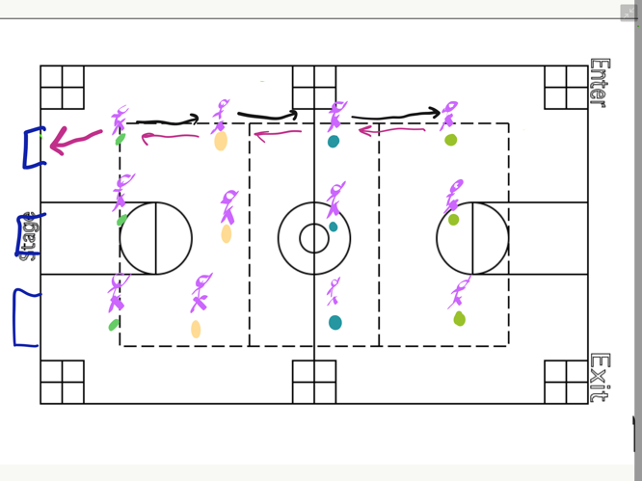
7 min | 3 on 2s  In groups of 5, 3 students will be on offense and 2 students will be on defense. The person with the ball is the passer and cannot move. The other person is the receiver and will be covered by the defender. Where the offender moves, the defender moves. Passes must be attempted in 10 seconds or less, and once the pass has been attempted, the receiver becomes the thrower and the defender now moves to the uncovered target. One the defender is set (ready), the ten seconds start.  After everyone on the offense has touched the ball/puck, they must try and score a goal. After a shot, regardless of a score or not, the  Students should stay inside of a 20x20 square, dictated by cones. | Just like we did yesterday, the offense needs to be wearing pennies. Does everyone on offense have to touch the ball before a shot? Yes. | 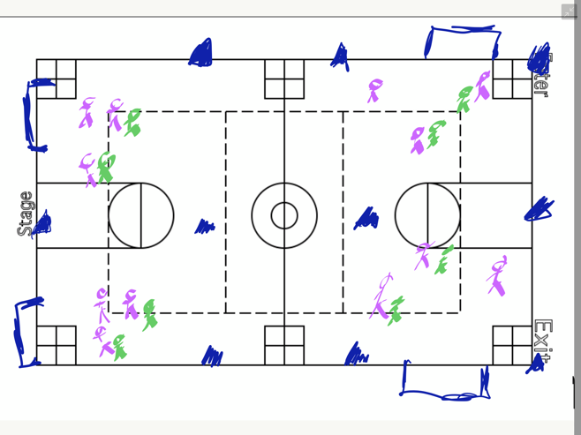
2 min | Introduction to gameplay:  Scooter Hockey is much like regular hockey. Remember that we can be moving only forward, there is no backwards scooting. Everyone on your team must touch the ball before you score a goal. If you take a shot and miss, you don’t have to have everyone re-touch the ball.  Goalies are optional, but if you choose to have one, you must rotate goalies after each time someone scores on you.
8 min | Gameplay:  In teams of 4 or 5, students will be playing Scooter Hockey following the rules mentioned above. As previously mentioned, if a student is in possession of the ball, they cannot move. Before a score can be marked, everyone on the team must possess the ball or puck. | Teams should be evenly divided based off ability level.  Safety: Gym should be divided into equal playing areas, cones marking the end zone lines with enough room at the back of each end zone that students will not crash into the wall. | 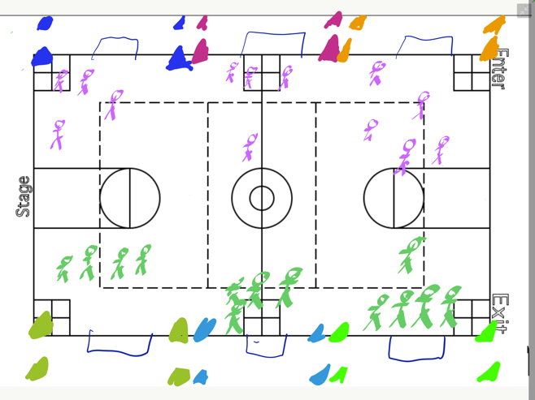
3 min | Discussion Question:  - What did you find a success while working in your teams?  Stretches: Hip flexor stretches, quads, hamstrings, shoulder and arms.  Shout outs: Who can shout out a classmate for demonstrating positive sportspersonship sometime during class? | Teacher Actions: Make sure that everyone is following the

Physical Education Plan
Jake Schafer  Disability Sport Unit  Sport: Scooter Hockey  Lesson Number: 4 | Equipment Needs:  1 scooter for every child  2 cones indicating lines to stand on  4 cones per group of 3 students
National Standards and Grade Level Outcomes:  Demonstrates respect for self and others in activities and games by following the rules, encouraging others and playing in the spirit of the game or activity. (S5.M6.6)  Transitions from offense to defense or defense to offense by recovering quickly. (S2.M6.6)  Shoots on goal with power in a dynamic environment as appropriate to the activity. (S1.M10.6) | Student Learning Objectives and Assessments:  - SWBAT make safe, accurate passes to everyone on their team during gameplay.  - SWBAT communicate with their team to plan for effective scoring during team-based practice tasks.  - SWBAT shout-out a classmate at the end of class, looking out for positive sportspersonship, acceptance of others, and playing fairly.

Time (min) | Task Details | Performance Cues  (Teacher Actions + safety reminders) | Organization
2 min | Introduction and review of previous material:  Offense and Defensive strategies, gameplay. What strategies did you find successful/what would you like to see more of with your team?  We are going to play Scooter Hockey All day today with an assessment at the end. You’ll have the first five minutes to warm up with your team. I should see everyone on your team active and engaged, focusing on passing, scoring, and communicating.  Goal for the day:  Be on the lookout today for a classmate who’s demonstrating positive sportspersonship, acceptance, or making the learning environment inclusive. Shout-outs at the end.  Transition:  I need you to go toe-to-toe with a person next to you. The shorter person grab a scooter for both you and your partner, while the other grab a puck or ball for you both. What are you doing when I say go? | Safety:  When we are on our scooters, we are only on our bottoms. If you are standing or kneeling or belly-flopping you are done for the day | Everyone meets in the middle of the gym, ready for instruction for the day.
5 min | Warm-up with your team:  I should see everyone on your team active and engaged, focusing on passing, scoring, and communicating.  Example activity: In teams of 5, the first minute is devoted to stationary passing to another student. With two balls present, students are responsible for calling out the person whom they’re passing the ball to next.  For the next 3 minutes, students are passing to a moving student moving towards a goal, saying their name before they pass. Once the student receives the pass, they may shoot on goal.  The final minute is devoted to shooting on goal, retrieving their ball and passing to a teammate so they have an opportunity to shoot. | When we are passing, what cues are we looking for? Absorb, eyes on the target, pass with force.  When we are moving, can we be moving backwards? No. | 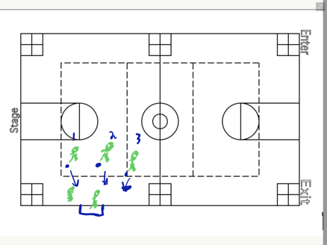  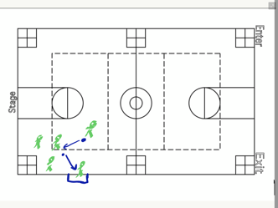  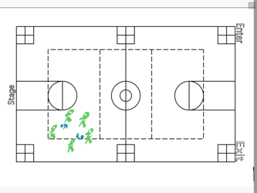
2 min | Review on gameplay:  Scooter Hockey is much like regular hockey. Remember that we can be moving only forward, there is no backwards scooting. Everyone on your team must touch the ball before you score a goal. If you take a shot and miss, you don’t have to have everyone re-touch the ball.  Goalies are optional, but if you choose to have one, you must rotate goalies after each time someone scores on you.
7 min | Gameplay:  In teams of 4 or 5, students will be playing Scooter Hockey following the rules mentioned above. As previously mentioned, if a student is in possession of the ball, they cannot move. Before a score can be marked, everyone on the team must possess the ball or puck. | Teams should be evenly divided based off ability level.  Safety: Gym should be divided into equal playing areas, cones marking the end zone lines with enough room at the back of each end zone that students will not crash into the wall. | 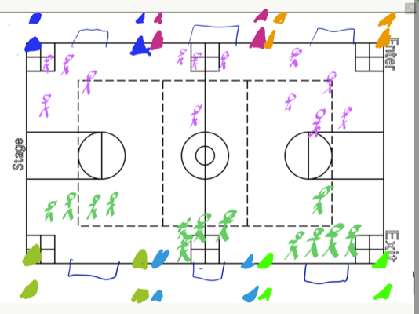
7 min | Gameplay:  In teams of 4 or 5, students will be playing Scooter Hockey following the rules mentioned above. As previously mentioned, if a student is in possession of the ball, they cannot move. Before a score can be marked, everyone on the team must possess the ball or puck. | Teams should be evenly divided based off ability level.  Safety: Gym should be divided into equal playing areas, cones marking the end zone lines with enough room at the back of each end zone that students will not crash into the wall. | 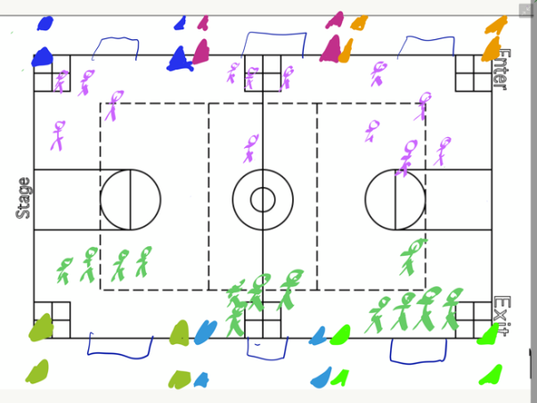
7 min | Gameplay:  In teams of 4 or 5, students will be playing Scooter Hockey following the rules mentioned above. As previously mentioned, if a student is in possession of the ball, they cannot move. Before a score can be marked, everyone on the team must possess the ball or puck. | Teams should be evenly divided based off ability level.  Safety: Gym should be divided into equal playing areas, cones marking the end zone lines with enough room at the back of each end zone that students will not crash into the wall. | 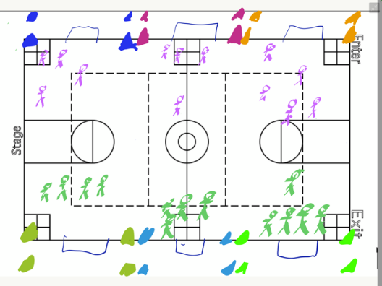
5 min | Final Discussion Questions (Written)  - What did you notice from the beginning to the end of the unit? What changed and why?  - How did you overcome fatigue with strategies or tactics?  - Was this experience rewarding to you and if so why? If not, why?  - How might you relate your experience to a person with a disability?  - Shout out someone on a different team who exemplified exceptional sportspersonship? What makes this person fun to be around? Would you want them on your team and why or why not?  Stretches: Hip flexor stretches, quads, hamstrings, shoulder and arms.  Shout outs: Who can shout out a classmate for demonstrating positive sportspersonship sometime during class? | Teacher Actions:  Be sure that students are evenly spaced out and have the necessary writing implements for the assessment.  When you’re Finished:  Discuss with a partner, someone not on your team on the discussion questions. Find similarities between the two of you and discuss the differences.

Sit Volleyball
Physical Education Plan
Jake Schafer  Disability Sport Unit  Sport: Sit Volleyball  Lesson Number: 1 | Equipment Needs:  1 beach ball/balloon for every 2 students
National Standards and Grade Level Outcomes:  Two-hand-volleys with control in a variety of practice tasks. (S1.M17.6)  Employs correct techniques and methods of stretching.11 (S3.M9.6) | Student Learning Objectives and Assessments:  1) SWBAT maintain a rally of 10 or more hits in a rally using a beach ball or balloon during practice activity time.  2) SWBAT communicate with a group, saying the name of the person they are passing to during practice activity time.  3) SWBAT compliment or shout-out classmates at the end of the class.

Time (min) | Task Details | Performance Cues  (Teacher Actions + safety reminders) | Organization
10 min | Introduction to Sit Volleyball:  Play clip of Sit Volleyball  https://www.youtube.com/watch?v=gGpAnbVrEiE  Start at 2:45 and go to 11:45  Discussion questions after the video:  - What do you notice about all the athletes? What do you notice about the physical abilities of the athletes compared to one another? Compared to you?  - What kind of disability do you think someone has if they’re playing witting volleyball and why?  - What skills are required in order to play the sport? What other skills in other sports can be used in order to be more successful in sitting volleyball?  Goal for the day for the class:  Be on the lookout today for a classmate who’s demonstrating positive sportspersonship, acceptance, or making the learning environment inclusive. Shout-outs at the end. | We’re going to start a disability sports unit. We’re going to play sit volleyball, a modification based off of traditional volleyball as played in the Paralympic Games.  Play video clip.  We’ll discuss full rules when we move into gameplay.  Go over discussion questions | Students gathered around projector screen
5 min | Roles and Responsibilities: Think-Pair-Share  For the entirety of the unit, from the time you enter the gym to the time you leave the gym, you are going to model as if you have a lower leg amputation. If your last name starts with A-M, you have a full right leg. If your last name starts with N-Z, you have a full left leg.  When we are moving, you will have to either crawl or hop on your full leg.  When we are practicing a skill, you must maintain contact with the floor at all times with at least one buttock. You may elevate to one side, but may not leave the floor.  Questions on the board:  - Why do you think I’m having you model this?  - What movements do you have? (Hop, crawl, or slide on bum)  - What are some potential challenges you might face? How will you overcome them? | Visual demonstration in association with elevating to make a hit while seated
5 min | Passing to a partner using a set:  We’re going to start with learning how to set to our partner from the sitting position. I need everyone to make a diamond with their index fingers and their thumbs in front of their body. Now raise your elbows to 90 degrees, then extend your elbows up. This is a set. This will be used in “setting” up a teammate for a hit later on.  When I say “Go” I need one partner to move to get a beach ball, and the other move to a pair of poly spots. Your partner will meet you at your poly spot pair.  After 3 minutes: Count to see how many sets you can hit in a row. Can anyone get above 25 without the ball hitting the ground? | Visual demonstration in association with verbal instruction  What shape do my index finger/thumb make? (Diamond). Where do I extend my arms? (Up).  What are the options for moving? (Hop, crawl, or slide) | 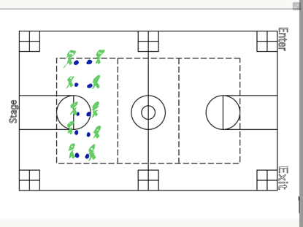
5 min | Passing to partner using a bump:  We’re going to move into bumping with our beach-balls. When we bump, one hand goes on top of the other, thumbs tucked in creating a table, forearms facing to the ceiling.  When I say “Go” you and your partner are going to practice ONLY bumping the ball to each other.  After 3 minutes: Count to see how many bumps you can hit in a row. Can anyone get above 25 without the ball hitting the ground? What are some challenges you faced with bumping the ball versus setting? | Visual demonstration in association with verbal instruction
6 min | Keep it up  When I say Go, I need you to join another group of 2, forming a group of 4. Leave your ball at your dots when you join the group.  Using both bumps and sets, your objective in your group is to keep your beach ball up and achieve the highest number of hits in a row remembering to keep your buttock on the floor only raising one side.  After 3 min: What’s your highest number you’ve achieved?  Try for 10 more than that number. Be sure we are using what kind of shape when we set? (A diamond)  What are our arms like when we’re bumping? (A table) | Visual demonstration with setting and bumping | 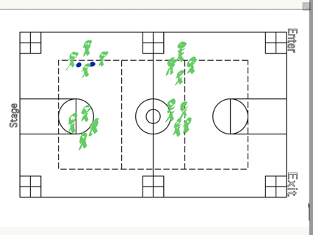
4 min | Stretch and Debrief  Questions:  - What did you find most difficult about today?  - Despite finding something difficult, how did you overcome that difficulty?  Stretches: Hip flexor stretches, quads, hamstrings, shoulder and forearms.  Shout outs: Who can shout out a classmate for demonstrating positive sportspersonship sometime during class? | Positive pinpointing, proximity control

Physical Education Plan
Jake Schafer  Disability Sport Unit  Sport: Sitting Volleyball  Lesson Number: 2 | Equipment Needs:  1 beach ball for every 2 students  1 poly spot for every student  1 pickleball net (or modified net using cones/noodles) for every 4-6 students
National Standards and Grade Level Outcomes:  Two-hand-volleys with control in a variety of practice tasks. (S1.M17.6)  Exhibits personal responsibility by using appropriate etiquette, demonstrating respect for facilities and exhibiting safe behaviors. (S4.M1.6) | Student Learning Objectives and Assessments:  1. SWBAT maintain a rally of 10 or more hits in Holcomb volleyball activity time.  2. SWBAT communicate with a group of 4 students on receiving a pass and maintaining a rally.  3. SWBAT compliment or shout-out classmates at the end of the class.

Time (min) | Task Details | Performance Cues  (Teacher Actions + safety reminders) | Organization
2 min | Introduction and review of previous material.  Goal for the day for the class:  Be on the lookout today for a classmate who’s demonstrating positive sportspersonship, acceptance, or making the learning environment inclusive. Shout-outs at the end. | Remember which leg is your full leg. (A-M is full right, N-Z is full left)  Yesterday we worked on bumping and setting from the seated position. What challenges did we have again? What can we do to make our passes successful? | Everyone meets in the middle of the gym, ready for instruction for the day.
5 min | Partner bumping and setting:  Using our bumps (hands like a table) and our sets (index finger/thumb form a diamond), we’re going to try for 30 hits in a row. If that’s too challenging, can anyone break 60? Remember that we can’t leave the floor. One buttock must maintain in contact with the floor at all times. | Visual demonstration for bumping, setting, and elevating while seated | 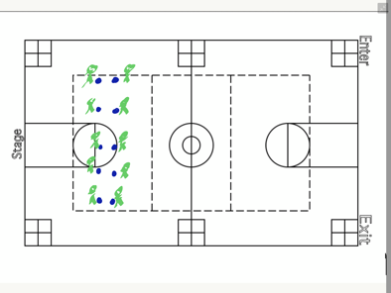
4 min | Partner Keep It Up:  Using bumps and sets, you and your partner are going to keep the ball up in the air. Continue to use bumps and sets, but if the ball goes too far away, we can also use our feet, or knees in order to keep the ball in play. Remember, can we leave the floor? | Visual demonstration for bumping, setting, and kicking the ball up.  Do we want to kick the ball just because? (No.)  Why would we want to kick the ball? (Last resort attempt).
2 min | Introduction to Serving:  We will be using real volleyballs today in preparation for playing a full game of sitting volleyball.  When serving in sitting volleyball, we serve from the end line on the court.  Our serve has two components:  Toss: Toss our volleyball with our non-dominant hand (What does that mean?)  With our dominant hand (What does that mean?) Strike the ball with the heel of the palm to send the ball over the net. We want to strike the ball out in front, just like we’re giving the ball a great big High-5!) | Visual demonstration on the serve. (Where the serve line is, where we contact the ball, what the toss looks like.)
7 min | Serving practice:  Students start from the red poly spot and move continually backwards to the end line. Once a student has hit the ball over and in 3 times at each dot, they may move one dot.  Transition: You will need one partner for this next activity. When I say “Go,” you and your partner need to find two dots close to one another and one volleyball for the two of you. | Visual demonstration, helping students visualize their toss and where they’re serving.  Safety: Our eyes need to be on the other side of the net, looking for balls that are coming our way.  Communication: Students will be serving to another person in the class. They must say their name before they serve so the recipient knows the ball is coming. | 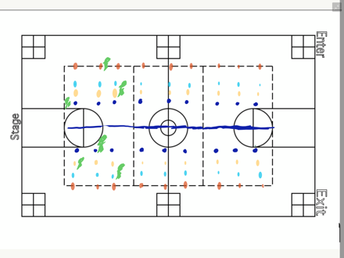
3 min | Introduction to gameplay:  We’re going to start gameplay today. When we’re playing, the person on the green dot (middle front) will throw the ball over to the other side. We will work on full serving tomorrow. The other team has as many hits as they need to get the ball back over. If the ball hits the ground or goes out of bounds, the point is over.  Rotation:  Each time a team wins a side out or gets possession of the serve, the new serving team rotates clockwise. Each player rotates one spot—the left front rotates to the middle front position, the middle front rotates to the right-front position, the right front rotates to the right-back position and so on.  This is so everyone gets an opportunity to play in every part of the court and serve an equal number of times.  Communication: I should hear you communicating with your team on passing and getting the ball over. | Visual demonstration of rotation, what happens when the ball lands out, which team rotates, where they rotate to.  Visual demonstration on where the sidelines are and what happens at the end of a point.
7 min | Gameplay:  In teams of 4-6, students play modified sitting volleyball.  No score, just rotate if your side won the rally. | Reminder on communication between teammates and serve rotation.  Remember we cannot leave the floor. | 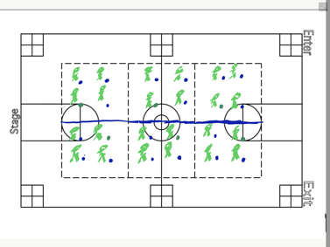
4 min | Stretch and Debrief  Questions:  - What did you find most difficult about today?  - What skills did you use today during gameplay that you’d used previously?  Stretches: Hip flexor stretches, quads, hamstrings, shoulder and forearms.  Shout outs: Who can shout out a classmate for demonstrating positive sportspersonship sometime during class? | Positive pinpointing, proximity control

Physical Education Plan
Jake Schafer  Disability Sport Unit  Sitting Volleyball  Lesson Number: 3 | Equipment Needs:  1 volleyball for every 2 students  1 pickle ball net for every 4-6 students  1 poly spot for every student, plus 20 extra dots for serving activity
National Standards and Grade Level Outcomes:  Performs a legal underhand serve with control for net and wall games such as badminton, volleyball or pickle ball. (S1.M12.6)  Cooperates with a small group of classmates during adventure activities, game play or team-building activities. (S4.M5.6) | Student Learning Objectives and Assessments:  1) SWBAT serve a volleyball with 75% accuracy during skill practice.  2) SWBAT communicate with teammate on receiving passes  3) SWBAT compliment or shout-out classmates at the end of the class.

Time (min) | Task Details | Performance Cues  (Teacher Actions + safety reminders) | Organization
2 min | Introduction and review of previous material.  Goal for the day for the class:  Be on the lookout today for a classmate who’s demonstrating positive sportspersonship, acceptance, or making the learning environment inclusive. Shout-outs at the end. | Remember which leg is your full leg. (A-M is full right, N-Z is full left)  Yesterday we worked on bumping and setting from the seated position and played a modified game of sitting volleyball. What challenges did we have? What can we do to make our passes successful? | Everyone meets in the middle of the gym, ready for instruction for the day.
6 min | Individual Warm-up:  Students will warm up their bumps and sets with themselves against the wall. (4 min)  Students will then slide back to warm up their serving motion, having the ball bounce off the wall and return to them. If there are not enough balls for every student to have one, students will rotate 30 seconds on, 30 seconds off with their partner. (2 min) | What shape do our hands make when we’re setting the volleyball? What should our arms look like during a bump? | 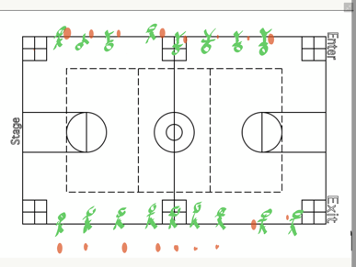
7 min. | Snake:  In teams of 12, students will arrange themselves in the front of the net, 6 on one side, 6 on the other parallel to the other team. The person on one end starts the ball and it must go in order to the other side, not skipping anybody on either side of the net. Once the ball has reached the end the snake ends.  Each team of 12 receives 7 balls. The first group to move all 7 balls from one side to the other wins.  Challenge round: The ball must go all the way down and all the way back before it is considered “complete.” | Remember one buttock must remain in contact with the floor at all times.  Will setting or bumping be more successful in this situation? | 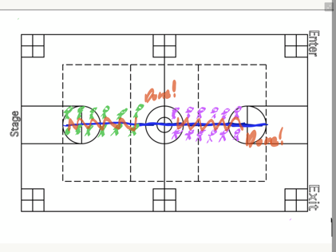
8 min | Gameplay:  In teams of 4-6, students play modified sitting volleyball.  No score, just rotate if your side won the rally.  Change from previous days: Your team only has 3 hits in order to get the ball over.  Rotation: Everyone is going to rotate one-half court to the right so there’s not a lot of crawling required. | Reminder on communication between teammates and serve rotation.  Remember we cannot leave the floor.  Visual demonstration for rotation  How many hits does your team have to get the ball over? | 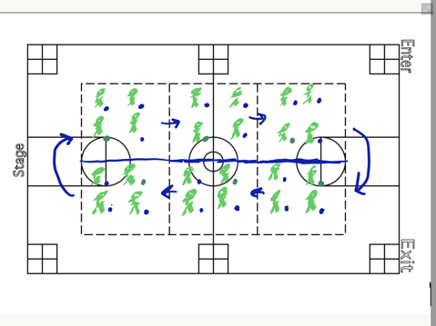
8 min | Gameplay:  In teams of 4-6, students play modified sitting volleyball. Students still have as many hits as they need to get the ball back over.  No score, just rotate if your side won the rally.  Remember where we serve from the end line.  Modification: If students are still struggling, they may move up one or two scooches into the court. | Reminder on communication between teammates and serve rotation.  Remember we cannot leave the floor.  How many hits do we get to try and get the ball over? | 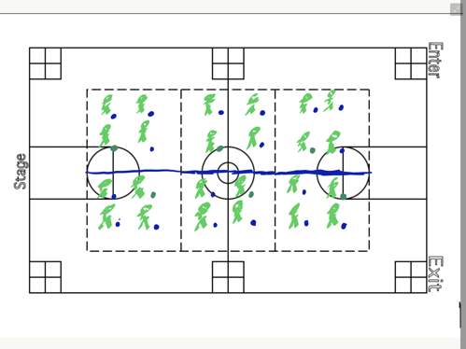
4 min | Stretch and Debrief  Questions:  - What did you have to change from a beach ball to a volleyball?  - What skills did you use today during gameplay that you’d used previously?  Stretches: Hip flexor stretches, quads, hamstrings, shoulder and forearms.  Shout outs: Who can shout out a classmate for demonstrating positive sportspersonship sometime during class? | Positive pinpointing, proximity control

Physical Education Plan
Jake Schafer  Disability Sport Unit  Sport: Sitting Volleyball  Lesson Number: 4 | Equipment Needs:  1 volleyball for every 2 students  1 pickle ball net for every 6 students  1 poly spot for every student
National Standards and Grade Level Outcomes:  Accepts differences among classmates in physical development, maturation and varying skill levels by providing encouragement and positive feedback. (S4.M4.6)  Strikes with a mature overhand pattern in a nondynamic environment for net/ wall games such as volleyball, handball, badminton or tennis. (S1.M13.6) | Student Learning Objectives and Assessments:  1) SWBAT maintain a 12 hit rally in which the volleyball travels over the net at least 4 times during gameplay.  2) SWBAT communicate with teammates on receiving a pass and volleying the ball over the net.  3) SWBAT compliment or shout-out classmates at the end of the class.

Time (min) | Task Details | Performance Cues  (Teacher Actions + safety reminders) | Organization
2 min | Introduction and review of previous material.  Goal for the day for the class:  Be on the lookout today for a classmate who’s demonstrating positive sportspersonship, acceptance, or making the learning environment inclusive. Shout-outs at the end. | Remember which leg is your full leg. (A-M is full right, N-Z is full left)  Yesterday we worked on serving and from the seated position and played a modified game of sitting volleyball. What challenges did we have? What can we do to make our passes successful? | Everyone meets in the middle of the gym, ready for instruction for the day.
4 min | Keep it up: Take 3:  When I say Go, I need you to join another group of 2, forming a group of 4. Leave your ball at your dots when you join the group.  Using both bumps and sets, your objective in your group is to keep your beach ball up and achieve the highest number of hits in a row.  After 3 min: What’s your highest number you’ve achieved?  Try for 10 more than that number. Be sure we are using what kind of shape when we set? (A diamond)  What are our arms like when we’re bumping? (A table) | Visual demonstration with setting and bumping | 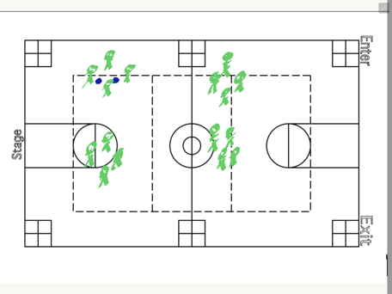
4 min | Serving practice:  Students start from the red poly spot and move continually backwards to the end line. Once a student has hit the ball over and in 3 times at each dot, they may move one dot.  Transition: You will need one partner for this next activity. When I say “Go,” you and your partner need to find two dots close to one another and one volleyball for the two of you. | Visual demonstration, helping students visualize their toss and where they’re serving.  Safety: Our eyes need to be on the other side of the net, looking for balls that are coming our way.  Communication: Students will be serving to another person in the class. They must say their name before they serve so the recipient knows the ball is coming.
7 min | Gameplay:  In teams of 4-6, students play modified sitting volleyball.  No score, just rotate if your side won the rally.  Rotation: Everyone is going to rotate one-half court to the right so there’s not a lot of crawling required. | Reminder on communication between teammates and serve rotation.  Remember we cannot leave the floor.  Visual demonstration for rotation
7 min | Gameplay:  In teams of 4-6, students play modified sitting volleyball.  No score, just rotate if your side won the rally.  Rotation: Everyone is going to rotate one-half court to the right so there’s not a lot of crawling required. | Reminder on communication between teammates and serve rotation.  Remember we cannot leave the floor.  Visual demonstration for rotation
6 min | Gameplay:  In teams of 4-6, students play modified sitting volleyball.  No score, just rotate if your side won the rally. | Reminder on communication between teammates and serve rotation.  Remember we cannot leave the floor.
5 min | Final Discussion Questions (Written)  - What did you notice from the beginning to the end of the unit? What changed and why?  - Was this version of volleyball easier, harder, or just different for you? Why?  - Was this experience rewarding to you and if so why? If not, why?  - How might you relate your experience to a person with a disability?  - Shout out someone on a different team who exemplified exceptional sportspersonship? What makes this person fun to be around? Would you want them on your team and why or why not?  Stretches: Hip flexor stretches, quads, hamstrings, shoulder and arms.  Shout outs: Who can shout out a classmate for demonstrating positive sportspersonship sometime during class? | Teacher Actions:  Be sure that students are evenly spaced out and have the necessary writing implements for the assessment.  When you’re Finished:  Discuss with a partner, someone not on your team on the discussion questions. Find similarities between the two of you and discuss the differences.

Considerations
Class size
Class size is especially important when it comes to Goalball especially. There are 3 marks on a Goalball court, one for each goalie position. In the lesson plan, there are teams of four, allowing one person on each team to retrieve the ball and set it in front of the left goalie. There are three courts in the lesson plans, although you are free to modify the lesson plan/organization as you see fit. The disability sports curriculum does lean towards a class size no larger than 24. Small-sided games allow for more touches per student, increasing time on task and overall enjoyment of the activity.
Equipment
Equipment for the Disability Sports Curriculum can be expensive if there’s not already equipment accessible for you. While many districts have scooters, not all have pickleball nets, scooter hockey sticks, or goalballs. The most obvious concern of the three is goalballs. A regulation goalball costs anywhere from $55 to $85. Soccer balls with bells in them do exist, and are far less expensive, in the $20-30 range. You probably will not have this equipment in your schools, so it is up to you to decide whether the cost of the equipment is worth the experience for the students. If you were to split the cost with another school and share the equipment when you are done, then the cost goes down and feasibility of using the equipment again goes up. As with any of the equipment not readily available to you, it’s up to you in determining whether or not you’ll use the equipment after the disability sports curriculum, and what the overall cost effectiveness is when it comes to providing educational opportunities to your students.
Trust and Acceptance
The biggest factor in introducing a disability sports unit. Do you as the teacher feel as though your students can act in a safe and inclusive environment that promotes achievement of others, spotlighting inclusivity rather than limitations? If the answer is no, do you feel as though through units such as these that they could get to that point? Just something to ponder. The hope is that we treat everyone, regardless of ability with the same respect we treat our best friends. We as humans want to be treated fairly and have meaningful relationships with others. Trust is built over time and through continued positive interactions, especially through sport, students have the opportunity in trusting and accepting one another, regardless of ability.
Safety
Similar to trust and acceptance is safety. Goalball is a sport for the visually impaired and all athletes wear blackout eyeshades. With the activities, trust of the students must be achieved first, ensuring that no one in the class is going to run into a wall or each other while not being able to see. The purpose is to gain understanding and be intentional about learning what it’s like to not have eyesight. With activities such as these, setting the standard for what’s expected of the students and laying the law for the consequences if safety is violated is crucial for everyone’s safety. There are other “blind activities” common in the adventure-educational model that you can use in association with the ones in the goalball unit. As is expected in adventure-education, trust is built up and if group trust is not achieved, trust activities will not be taught. You know your students. Will they be able to roll a ball at a safe speed to another member of their class, both of whom cannot see but only hear the ball?

Resources
Davis, R. W. (2010). Teaching Disability Sport: A Guide for Physical Educators (2ndnd ed.). Champaign, IL: Human Kinetics.
USA Goalball: https://www.usaba.org/usa-goalball/
Getting involved in Adapted Athletics: https://www.challengedathletes.org/adaptive-sport-organizations/
Foley, J. T., Tindall, D., Lieberman, L., & Kim, S. (2007, November). How to Develop Disability Awareness Using the Sport Education Model. JOPERD, 78(9), 32-36.

Godeau, E., Vignes, C., Sentenac, M., Ehlinger, V., Navarro, F., Grand Jean, H., & Arnaud,
C. (2010). Improving attitudes towards children with disabilities in a school context: A cluster randomized intervention study. Developmental Medicine and Child Neurology, 52, e236–e242.

Greiner, M., Collins, K., & Wright, S. (2014). Perceptions of a Disability Sport Unit in General Physical Education. Adapted Physical Activity Quarterly, 31, 49-66.

Grenier, M., & Kearns, C. (2012). The benefits of implementing disability sports in physical education. Journal of Physical Education, Recreation & Dance, 83(4), 23-27.

Grenier, M. (2007). Inclusion in physical education: From the medical model to social constructionism. Quest, 59(3), 298–310.

Panagiotou, A.K., Evaggelinou, C., Doulkeridou, A., Mouratidou, K., & Koidou, E. (2008).
Attitudes of 5th and 6th grade Greek students toward the inclusion of children with dis- abilities in physical education classes after a Paralympic education program. European Journal of Adapted Physical Activity, 1(2), 31–43.

Shapiro, D. R., Pitts, B. G., Hums, M. A., & Calloway, J. (2012, November 1). Infusing disability sport into the sport management curriculim. International Journal of Sport Management and Marketing, 8(1), 101-118.

References
Adaptive Sport (2020). In Physiopedia. Retrieved from https://www.physio-pedia.com/Adaptive_Sport

Barton, L. (1993). Disability empowerment and physical education. In J. Evans (Ed.), Equality, education and physical education. (pp. 43–54). London: Falmer Press.
Barber, W. Inclusive and accessible physical education: rethinking ability and disability in pre-service teacher education. .

Block, M. (1995). Development and validation of Children’s Attitude Towards Integrated
Physical Education, Revised (CAIPE-R) Inventory. Adapted Physical Activity Quarterly, 12, 60–77.

Block, M.E., & Obrusnikova, I. (2007). Inclusion in physical education: A review of the literature from 1995-2005. Adapted Physical Activity Quarterly, 24(2), 103–124. PubMed
Davis, R. W. (2011). Teaching Disability Sport (Second ed.). Champaign, IL: Human Kinetics.
Davis, R., Rocco-Dillon, S., Grenier, M., Martinez, D., & Aenchbacker, A. (2012). Implementing disability sports in the general physical education curriculum. Journal of Physical Education, Recreation & Dance, 83(5), 35-41.

Evans, J. (2004). Making a difference? Education and “ability” in physical education. European Physical Education Review, 10(1), 95–108.

Foley, J. T., Tindall, D., Lieberman, L., & Kim, S. (2007, November). How to Develop Disability Awareness Using the Sport Education Model. JOPERD, 78(9), 32-36.

Godeau, E., Vignes, C., Sentenac, M., Ehlinger, V., Navarro, F., Grand Jean, H., & Arnaud,
C. (2010). Improving attitudes towards children with disabilities in a school context: A cluster randomized intervention study. Developmental Medicine and Child Neurology, 52, e236–e242.

Greiner, M., Collins, K., & Wright, S. (2014). Perceptions of a Disability Sport Unit in General Physical Education. Adapted Physical Activity Quarterly, 31, 49-66.

Grenier, M., & Kearns, C. (2012). The benefits of implementing disability sports in physical education. Journal of Physical Education, Recreation & Dance, 83(4), 23-27.

Grenier, M. (2007). Inclusion in physical education: From the medical model to social constructionism. Quest, 59(3), 298–310.

Hehir, T. (2007). Confronting ableism. Educational Leadership, 64(5), 9–14.
Hunt, C. S., & Hunt, B. (2004). Changing Attitudes Toward People with Disabilities: Experimenting with an Educational Intervention. Journal of Managerial Issues, 16(2), 266-280.
Hutzler, Y. (2003). Attitudes toward the participation of individuals with disabilities in physical activity: A Review. Quest, 55(4), 347-373.

Kalyvas, V., & Reid, G. (2003). Sport adaptation, participation and enjoyment of students with and without disabilities. Adapted Physical Education Quarterly, 20, 182–199.

Kugelmass, J.W. (2004). The inclusive school: Sustaining equity and standards. New York: Teachers College Press.
Mckay, C. (2013). Paralympic school day: A disability awareness and education program. Palaestra, 27(4), 14-19

McKay, C., Block, M. E., & Yeah Park, J. (2015, October). The Impact of Paralympic School Day on Student Attitudes Toward Inclusion in Physical Education. Adapted Physical Activity Quarterly, 32, 331-338.

McLaren, H. (2010, June). Physical Education and Physical Activity. .

Panagiotou, A.K., Evaggelinou, C., Doulkeridou, A., Mouratidou, K., & Koidou, E. (2008).
Attitudes of 5th and 6th grade Greek students toward the inclusion of children with dis- abilities in physical education classes after a Paralympic education program. European Journal of Adapted Physical Activity, 1(2), 31–43.

Rieser, R., & Mason, M. (1990). Disability equality in the classroom: A human rights issue. London: ILEA.

Shapiro, D. R., Pitts, B. G., Hums, M. A., & Calloway, J. (2012, November 1). Infusing disability sport into the sport management curriculim. International Journal of Sport Management and Marketing, 8(1), 101-118.

Yun, J., & Beamer, J. (2018, April 10). Promoting Physical Activity in Adapted Physical Education. JOPERD, 89(4), 7-13.

