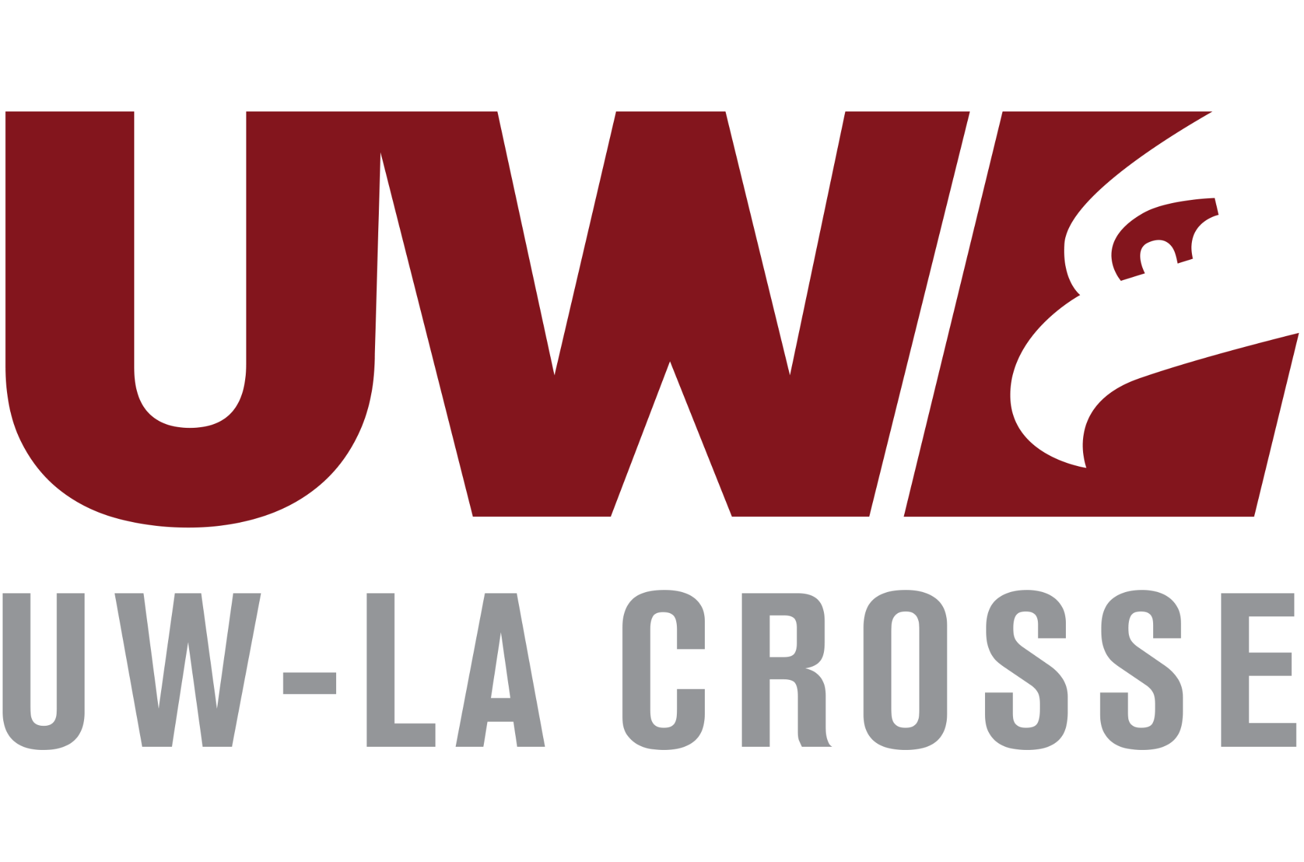 Eagle Advantage-SRC Peer Mentor and Researchers

Communication: Articulate thoughts and ideas clearly and effectively through written and oral communication. Tailor messaging for different audiences and contexts. Understand the impact of communication on your professional work image. Use communication skills to motivate others and work collaboratively

Comments:

Improvements:

Collaboration & Leadership: Build mutually beneficial relationships and achieve common goals by understanding, valuing, and leveraging strengths of others. Take responsibility for your own role and contributions within a team.

Comments:

Improvements:

Critical Thinking and Problem Solving: Exercise reasoning to independently analyze issues, identify options and alternatives, formulate opinions, make decisions, and overcome problems

Comments:

Improvements:

Digital Literacy & Technology: Leverage knowledge of information and communications technology to ethically and efficiently solve problems, complete tasks, and accomplish goals.

Comments:

Improvements:

Career & Self-Development: Proactively develop oneself and one’s career through continual personal & professional learning, awareness of one’s strengths and weaknesses, navigation of career opportunities, and networking to build relationships both within and outside of one’s organization.

Comments:

Improvements:

Adaptability: Recognize challenges as opportunities to improve. Embrace a growth mindset that allows for action, reflection, failure, and resilience.

Comments:

Improvements:

Diversity, Equity, & Inclusion: Cultivate awareness of your own identity and that of others through exploration of diversity. Demonstrate the awareness, knowledge, and skills required to equitably engage and include people from different local and global cultures. Engage in practices that actively challenge oppressive systems, structures, and policies.

Comments:

Improvements:

Accountability: Knowing work environments differ greatly, understand and demonstrate effective work habits, and act with interests of the larger community and workplace in mind.

Comments:

Improvements:

Other thoughts or recommendations:

